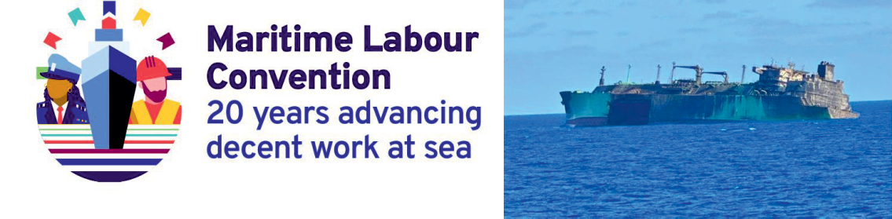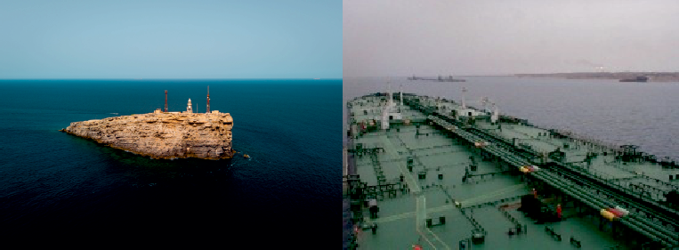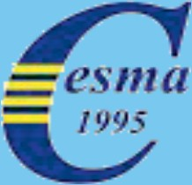

CONFEDERATIONOFEUROPEANSHIPMASTERS'ASSOCIATIONS
MARCH 2026

INTHISISSUE:
- WARINARABIAN/PERSIAN GULF
- WHENGEOPOLITICENTERSGLOBALMARITIME TRADE
- 1STSUMMERSCHOOL,LEHAVRE–FR
- STORYABOUTTRSTENIKISLETINCROATIA

CESMANEWS
MARCH2026

CONFEDERATIONOFEUROPEANSHIPMASTERS’ASSOCIATIONS

SECRETARIAT: MUNTPLEIN10
NL-1012WRAMSTERDAM THE NETHERLANDS
TEL:SEELISTOFBOARDMEMBERSBELOW
e-mail: info@cesma-europe.orgwebsite:https://www.cesma-europe.org

PRESIDENT: CAPT.D.DIMITROV,BULGARIA Mob: +359 888 340 160
e-mail:president@cesma-europe.org private: mitko652012@yahoo.com

DEPUTYPRESIDENT: CAPT.G.RIBARIC,SLOVENIA
Mob:+38631375823Home:+38656772642
e-mail: deputy.president@cesma-europe.orgprivate: jrg.ribaric@gmail.com

VICEPRESIDENT: CAPT.M.BADELL,SPAIN
Mob:+34680321138Home:+34934089288
e-mail:vice.president@cesma-europe.orgprivate: badellmariano@gmail.com

SECRETARY-GENERAL: CAPT.H.ARDILLON,FRANCE
Mob: +33609450057 Home: +33 235 801 505
e-mail:general.secretary@cesma-europe.orgprivate: hubert.ardillon@gmail.com

ADMINISTRATOR: CAPT.H.AMMERLAAN,NETHERLAND
Mob:+31646260 098
e-mail: administrator@cesma-europe.orgprivate:h.ammerlaan56@gmail.com

WEBMASTER: CAPT.D.LAKOS,CROATIA Mob: +385 98 433 685
e-mail:webmaster@cesma-europe.orgprivate: damirlakos@gmail.com
Opinionsexpressedinarticlesarethoseofthesourcesand/orauthorsonly

ALOOKONACONFLICTIMPACTINGTHEMERCHANT NAVY
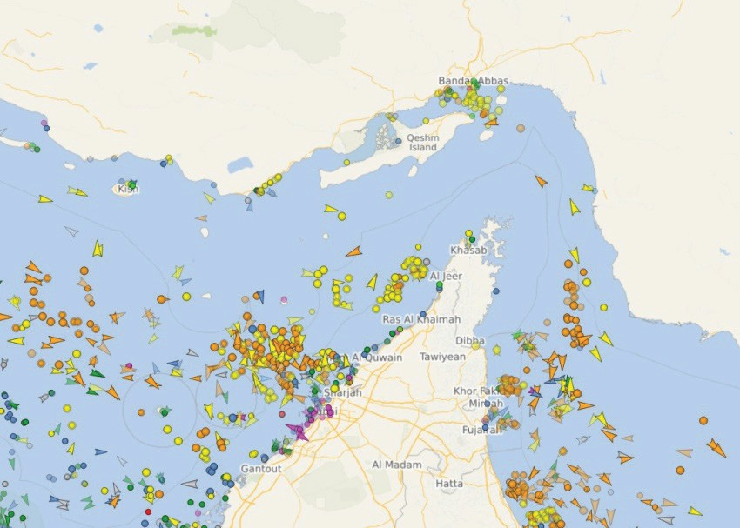
Strait of Hormuz
War in Iran, the impact on oil prices is significant. Small reminder: the 2nd oil crisis at the end of the 1970s was a consequence of the Iranian revolution. Will it be the same this time? No one knows yet. However, there is an essential difference between these two events: this time the merchant ships are heavily impacted; the Strait of Hormuz, when these lines are written, is not borrowed for fear of ats of war.
1st consequence: an impressive number of commercial ships, and therefore crews, are blocked, and therefore, de facto, prevented from heading towards a free and safe space for navigation. Every day, merchant ships are attacked by missiles or drones.And theArab-Persian Gulf being mainly known for its production and export of petroleum products (crude, refined,gas or chemicals), attacking one of these ships, loaded of course, even and perhaps especially at anchor, is synonymous with danger firstly for this ship but also for all those around it.
Sailingonashipcarryingdangerouscargoisnot,asyoucanimagine,themostpeacefuljob, coolastheysaynow,thatyoucando.Usually,sointhemiddleofaconflict,asapossiblecollateral victim of sorts, it’s easy to imagine it being an even more stressful job.
Thecaptainofsuchashipis,asheknows,alwaysresponsible.Butwhatcanhedoaboutit?
Navigation: To a French radio journalist who asked me how a merchant ship could hide in theArabianGulf,howtoescapeapossiblebombardment,Irepliedthattherewasnoplacetohide. StayingadriftorgoingtoanchorneartheUnitedArabEmiratesisasafetylure.Ontheotherhand, itisnecessarytoensurepermanentandmorethanattentivevisualandauditorymonitoring.Inthe mid-1980s, I remember sailing on a gas tanker (butane and propane on board) in this area then in the grip of a conflict between Iran and Iraq. We were not supposed to sail during the day, and at nightitwasall(navigation)lightsturnedoffandportshidden.Once,wehadanchoredfortheday, andthecaptaindecidedtoleaveinthemiddleoftheafternoon.Shortlyafterwelefttheanchorage, acolumnofsmokerosebehindus,mostlikelycomingfromwherewewereanchoredwithanother ship.Sowheretogo?Theanswerissimple:nowhere.Theonlysolutionistoleavethegulf,butthe straitnotbeingpracticableandunderveryhigharmedsurveillance,attemptingapassagebyforce, orevenontheslyonamoonlessnight,isachallenge,madness.TheshipsblockedintheGulfwill beblockedaslongasitisnotpossibletotransittheStraitofHormuzincompletesafety,whynot in a small convoy under the surveillance and escort of military ships, those which are armed.

Cargo:Aship stuck in the gulf, drifting or at anchor, what happens to its cargo? Of course she is always on board, as long as there is no leak due to the tearing of the hull/double hull following an attack. But what happens to its quality?Aquick reminder for non-experts who read this text: at the end of loading a liquid bulk cargo, in addition to the bill of lading, a certificate of quantityandacertificateofqualityofthecargoisissued.Isthereariskofdamagetothecargoin thelongterm?Probablynotorveryfewforcrudeoil,refinedproductsorgasbutwhataboutother cargoes such as chemicals. Of course we can reasonably think, hope, that the captain will not be held responsible for damage to the product, after all it is not his fault if his ship is blocked in the gulf and cannot transit through the Strait of Hormuz, the only access point to this gulf. But the worstisnevercertain,youneverknow,adesiretoblameacaptaincanverywellcrossthemindof a ship-owner or charterer.
Technique:Ashipwearsoutandevenmoresowhenitisnotsailing.Thehullbecomesdirty, thusaffectingtheenergyperformanceoftheship.Asfortherotatingparts,mainengineandother various devices of the machine, if stopping is often synonymous with the best time to carry out maintenance, in this case this cannot really apply. In view of the surrounding safety and security circumstances, it is unthinkable to dismantle even one injector on the main engine, in order to remainpermanentlyinanemergencyequipmentsituation.Soveryfewornomaintenanceorwork that can be carried out is not ideal for the ship; and same for the crew (see below).
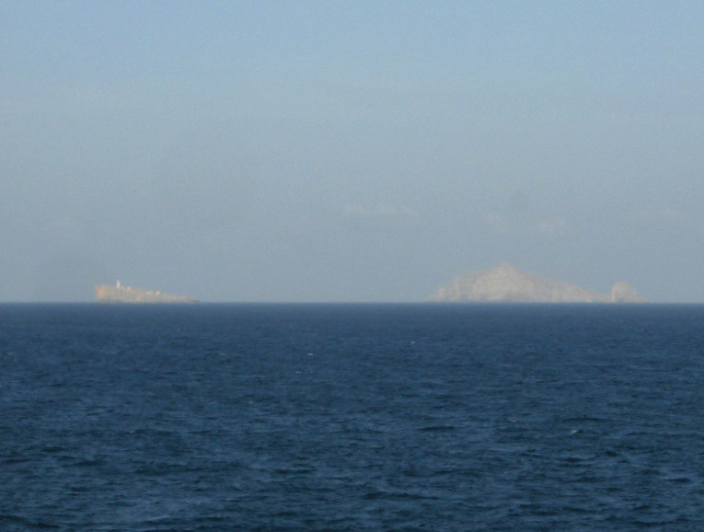
StraitofHormuz:LittleQuoin(Didamar)&GreatQuoin(Mumar)
Crew: But the most important thing, also for the captain, remains the management of the crew: the people on board of course, but also the food, the water or rather the water (drinkingand waste). Drinking water is produced on board, most of the time ship en route. Vessel stopped this can sometimes be done in very small quantities, at best, or not at all. Hence a lack of potable waterwhichwillinevitablybefeltifthesituationdragsonforawhile.Sewageisanotherproblem. The recovery boxes continue to fill up. But the discharge of wastewater into the sea is highly regulated – see MARPOLAnnex IV – among other things under conditions of distance from the coast and minimum speed of the vessel. What is more or less short term will represent serious problems for ships and captains.
Food:forthemoment,butweareonlyatthestartoftheconflict,thereisalwaysthepossibility of resupplying. But for how much longer, and at what cost?

Themenandwomenonboard:Firstthereisstress,fear.Thecommercialsailorisnotmilitary; he has neither been educated nor trained for conflict. He’s a civilian. There is a fear, there has alreadybeen,thatsomewillbecomewhatwecall“collateralvictims”.Aboveall,itisaprofound and significant test to remain inactive and waiting. It is also not absurd to think that many of these stranded sailors are in the process of making their last embarkation, which we have already experienced during the Covid period. The sailor knows stress; he lives with it almost daily. But it’s a work stress. This is something else: inaction which reinforces the feeling of powerlessness in the face of the immediate environment. The action is beneficial; it allows us to “forget” the environmental circumstances during this period of time that is work.We can talk about the well- being of sailors, but today for sailors stuck on the wrong side of the Strait of Hormuz, it is less about well-being and more about survival.
Andwecometotheroleofthecaptain.Heprobablyhasn’tlearnedhowtohandlethiskind ofsituation,andtheprocedurestohelphimdon’texist.Thecaptainmustmanagehisownstressas well as that of his crew. So of course there is the magic word: “the next generation”.Technically speaking,itisstillpossible,aslongasplanescanlandintheUnitedArabEmirates.Butsuccession is subject to one essential condition: finding a replacement. Yes, it is possible and it has been done to disembark without replacing the excess sailors – excess compared to the safe manning certificate. With a big downside, this certificate gives the list of crew members essential to the smooth running of the ship in complete safety to connect pointAto point B. In complete safety, thatmeanswithoutanythingabnormalhappening.Canwereallyspeakof“completesecurity,and even safety” in such an environment?And for the others, the essentials, who wish to be relieved, areplacementmustbefound.Andwhateversomejournalistssay,sailorswhowouldvolunteerto join a ship stuck in the Gulf are not as numerous as they think.
Andalwaysabove,andatthesametimewith,thereisthecaptain.Thecaptainisresponsible, amongotherthings,forthephysicalandmoralhealthofhiscrew.SoIaskthequestion:howcould such a responsible captain be relieved, leaving the other members of his crew on board?
Soyes,onemightthinkthatitiseasyforme,Iamnolongeractive,toanswerthisquestion.
ButIhonestlythinkIwillstaywithmycrew.Andthatwouldn’tmakemeavolunteer...
Capt.HubertARDILLON CESMASecretaryGeneral

CESMACOUNCILMEETING27JANUARY2026
The first on line CESMA Council meeting was done on 27thJanuary 2026 from 15:00 to 16:00 CET. As decided during last CESMAAGA the Board orginized the on line meeting via GooglemeetplatformafterreleaseofCESMANewsDecember2025.Theagendaofthemeeting was:
- CESMANewsDecember 2025-information fromthePresident andSGand discussion;
- CESMAAGAinformation2026and2027;
- Others
The meeting was moderated by CESMA President Capt. Dimitrov. The participants’ microphonesshouldbemutedexcepttheonewho’sgiventhefloorfromtheorganizer/moderator. There were 14 participants from 11 associations, of course not included the 3 members who had send just before the meeting an apology.

Capt. Dimitrov announced the agreed agenda and then said few words about Capt. Thierry Rossignol, CESMA vice president 2004-2006 and CESMA president 2006-2009, who passed awayonDecember9th,2025.CESMASecretaryGeneralCapt.HubertArdillonalsoexplainedthe role of Capt. Rossignol inAFCAN and CESMAand his input in both organizations.
SGandthePresidentgavedetailedinformationaboutEMSAConferenceandEMSAsafety reportwhichcouldbedownloadedfromEMSAwebsite(https://www.emsa.europa.eu/publications/item/5598-emsafe-report-2025.html).Itwasalsosaidthatsuchreportcanbedownloadedinthe27 different European national languages.
TherewasnoparticipantfromAVCCMMbutSGandthePresidentinformedtheparticipants aboutdevelopmentsofthe preparation and organization of next CESMAAGAin Bilbao.TheAGA will be at Bilbao Maritime Museum, there are already a number of proposed hotels but the place for the gala dinner is not yet confirmed which delayed the final message for registration. It’ll be done soon upon confirmation of the gala dinner.
Capt. Ivica Fazo presented himself as the new President of the ShipmastersAssociation of Montenegro and the new Board.
Therewasgeneraldiscussioninwhichalmostallparticipantstookpart.Capt.DamirLakos, Croatian representative and web master informed about instalation on board the ships of newAI equipmentgivingadvisesaboutship’srouteandactionsdependingupontheinformationcollected from ship’s systems. Capt. Trevor Crowley from IIMM raised the matter of responsibility about using such equipment if not class and flag approved. Capt.Antonio Raggi from USCLAC shared USCLACmemberexperiencethattheresponsibilityoftheuseofAIequipmentshouldbeforthe owner of the ship, P+I would not take part of the charges.
Thentheproblemsofthedarkfleetandimpairofthesafetyofnavigationwerediscussed.
SGinformed about the arrest of the captain of the sanctioned ship in France.
Capt. Mertens from VDKS confirmed that in 2027 VDKS will host CESMA AGA in Hamburg. He shared the opinion of members of VDKS that during AGA the situation with autonomous ships and their legal status and responsibilities have to be discussed.Also he raised the problem of the possibility of ships’crew to go ashore.There is less time in ports, there is less crew on board the ships and there are complications with some nationalities to obtain permission to go ashore in some countries especially in Europe.The matter will be included in the agenda of nextCESMAAGA.ThatwassupportedbyCapt.RaggiandCapt.Crowley.Capt.Raggiinformed the participants about the problems with the decreased crew on board ships and the possibility to becompliantwithhoursofworkandrestonboardshipsforthemasters.Samewasconfirmedby Capt. Crawley that during calls there more and more works and demands. And even, with high communications, if all is organized before the call, all can be changed at the last moment. But in casetherecordsofworkingandresthoursarenotcompliantwiththeregulation,themasteristhe one to be responsible.
Capt.LakosinformedonthevenueofaninternationalconferencetobeheldinSplit,Croatia, on 8-9 October 2026, with the possibility for CESMABoard members to assist, and/or to speak, during this IAMU Annual Conference.
It is already reminded to participants that CESMABoard should be renewed in 2027, and that allAssociations are required to already check internally for an application.
NextCESMAonline council meetingwill beinApril 2026.
Capt.DimitarDIMITROV,PHD,FNI
CESMAPresident

WHENGEOPOLITICSENTERSGLOBALMARITIMETRADE NOVEMBER 20, 2025 – LE HAVRE, FR
ThedaywasopenedbyMr.FrançoisLAMBERT,DirectorGeneralofENSM.Geopolitics andglobaltradearetwoconsubstantialentities.Asworldtradeislargelymaritime?thisstudyday will talk about maritime routes, their challenges, the risks they represent, including cyber risk.
Axis1:Strategicmaritimeroutesandgeopolitical issues
Inarecordedvideo,ViceAdmiralChristopheCLUZEL,commanderoftheNavalAction Force (NAF), begins his speech with “The sea is a new field of conflict”. Previously, the sea was aspaceoffreedom,warwaswagedatsea,anditwasdecidedfromland.Today,theseaisaspace where anything goes. It is not uncommon for the sea to attack land positions far from the coast. And fortunately for the commercial navy, the state navy protects commercial ships. Operation ASPIDES, in the Red Sea, involves more than 150 ship escorts.
The strategic fleet is the precious elements (the eyes of the crews, the radar images on the bridge)whichtransmitalltheobservations.Andwecanconsiderinstallingsensorsinthemastsor on the upper gangways of commercial ships.
Another key idea: the NAF is ready to receive and “educate/train” the reserve which has been doubled for this.
FortheViceAdmiralPascalAUSSEUR,generaldirectoroftheMediterraneanFoundation forStrategicStudies(FMES),currentlythedangeratseaiseverywhere,andthisislikelytolastat least50years.Therearetensionseverywhere:RedSea,ChinaSea,IndianOcean,GulfofGuinea, Caribbean Sea,Arctic zone. It is not a crisis but a breaking point.The difference compared to the crisis, where we end up returning to the initial state, is that we do not know the final state, except that it will be different from the initial state, and that this final state will not correspond to the European (or Western) model.
The model is trade, and the sea is the system that irrigates this model. But the model is exploding, in 70 years, we have gone from 3 to 8 billion human beings. And at the same time, resources are becoming scarcer. So there won’t be something for everyone.This inevitably leads to tensions.
Thishasseveralimpactsonthemerchantnavy.
Firsttherulesofthegamedisappear,includingtheregulations.Everyday,internationallaw isnotrespected,anditisthesameforthemaritimesector.WhenanEEZisdecreedasaterritorial zone by a country (Russia, China, Turkey), it is illegal. The rising powers are continental, not maritime, and there are increasingly strong ways to take ownership of the sea.
Then the return of geography (identity, nation, particularities, personal interests), and distances shortened. Everyone has their own identity, their own interest, their logic, their habits, and this is felt more and more in the merchant navy where the crews are multi-national.
Beforetheeconomyguidedtheworld,nowStatesmakedecisionsguidedbygeopolitics,or geo-economics.
But it can be good for the merchant navy because the flag, the strategic fleet, becomes important again.
Roundtable:Thegeopoliticalchallengesofmaritimeroutes
Moderator:Mr.GilMIHAELY,publishingdirectorofthe“Conflicts”magazine.
Firstofall,thepointofviewofmaritimeinsurerswithMr.PascalDUBOIS,generaldirector oftheCommitteeofStudiesandServicesofMaritimeInsurers(CESAM).In2025,CESAM,an

EconomicInterestGroupbringingtogether23maritimeinsurercompaniesrepresenting1.1billion Euros, does not represent a single entity, but rather all of the ecosystems linked to the merchant marine.
CESAM’sactionisbasedonfour pillars:
- Thenetwork:181DamagePolicestationsspreadacross111countriesand117expertsfor the transport of goods, fishing, rivers and pleasure craft.
- Asystem for exchanging technical-accounting flows of co-insurance to make exchanges of flows more reliable and reduce management costs. Coinsurance is essential: a PC of 24,000 containers at a cost of $200,000 on average per container is a huge sum.
- Management of general average and major disaster files on behalf of the French market, managed by companies internally, consolidation and reinsurance.
- Arating of countries/zones to enable the continued delivery of “War Risks” guarantees, “extended” coverage specific to the French market, in collaboration through exchanges with the MICACenter, and contacts with the UK Navy.
With regard to conflict risks, 8 degrees of risk zones have been defined, the degree of insurance then depends on the zone, the type of goods, the flag of the ship, etc.
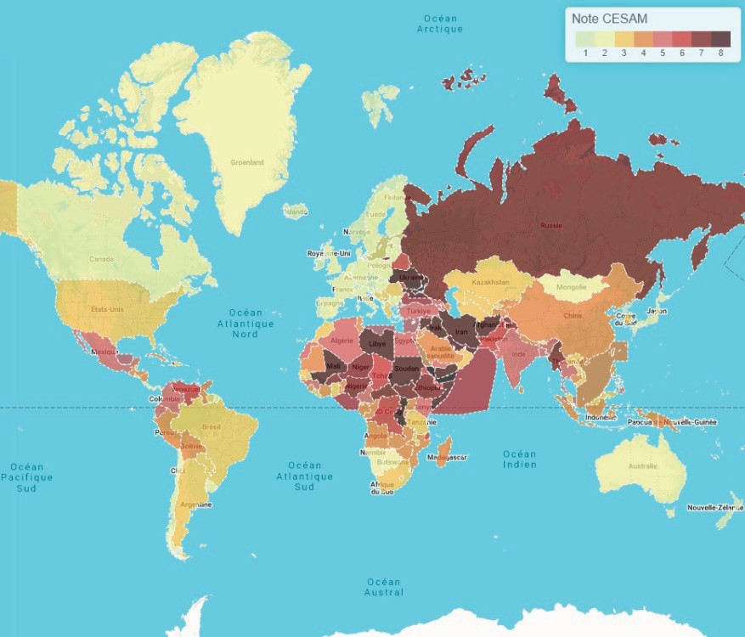
Mapofriskareasin2025
For10years,theriskduetocybercrimehasbeentakenintoaccount,takingcontrolofaship or a port.
Frigate Captain Thomas SCALABRE, MICACenter, gives the findings in 2024 and the trend in 2025 by zone of recorded events.
Drug trafficking reached record levels in 2024 with a 35% increase in cocaine production. In2025therewere20boatsdestroyed,mainlyinLatinAmerica.Semi-submersibleboatsnowgo everywhere,asfarasPortugal,evenoffthecoastofBrest.Thistypeofboatcosts1billionEuros, howeversmugglersarereadytosacrificeaboat,whichproves,ifnecessary,the“profitability”of smuggling.
Piracyand robbery:340 eventsin 2024and +15%for 2025.
The crisis in the Red Sea: 124 Houthi attacks in 2024 decrease in 2025 especially since the peaceprocessinPalestinewas established.Butin2025,there havebeenseveralshipsattacked or

evensunk,suchastheMagicSea,theEternityCandtheMinervagracht.Trafficisstillparalyzed, andthereisthereforestillaresidualriskintheRedSea.ThisriskwillexistaslongastheHouthis considerthemselvesonareligiousmission,since“thisisawarofexistence,notofborders”.Since the start of the crisis in the Red Sea,ASPIDES has provided 624 ship escorts, as well as around twenty openings of fire, on boats, drones or missiles.
Regarding the Gulf of Guinea, the security situation is slowly deteriorating. A group of pirates is located off the Cameroonian and Nigerian coasts, but it operates more near the equator. There were 39 incidents of robbery in “traditional” areas (Ghana, Nigeria,Angola) and 7 events of piracy.
The Gulf of Guinea is also a place to combat illegal, undeclared and unregulated fishing. Attacksoncommercialshipsaremainlycarriedoutwithaviewtokidnapping,especiallyatnight, and no mother ship has been identified.
Inaddition,theGulfofGuineaisanimportantlocationfordrugtrafficking,aswellasillegal bunkering.
IntheIndianOcean,therehasbeenanawakeningofpiracysincethebeginningof2024(42 eventsin2024andalready52in2025),withareturnofoffshorepiracyusingmothershipscapable of extending piracy up to 600 miles from the coast.
Finally, a “new thing” in 2025 with the “shadow” fleet which creates security and safety issues in European waters.
Capt. Pierre BLANCHARD, president ofAFCAN, explains the precautions taken before enteringariskzone,informationreceivedfromtheMICACenter,anddailypositions.Captainsare nottrainedtoassessthedegreeofrisk.Enteringazone,ornot,isnotaneasydecisiontomake.The captaincanbe“pushed”,influencedbytheownerandchartereroftheship:commerceaboveall(a trip by the Red Sea or SouthAfrica means an extra week at sea, therefore more consumption, air pollution, food, etc.). In addition, each crew member has their own life, their own experience. Of coursethereistherightofwithdrawal,whichisverygood,butonlyintheory.Inpractice,thiscan be very difficult, depending also on the contract linking the seafarer to the ship, and the practical feasibility of organizing a relief. So who can say no, apart from the captain (SOLAS V, 34-1)?
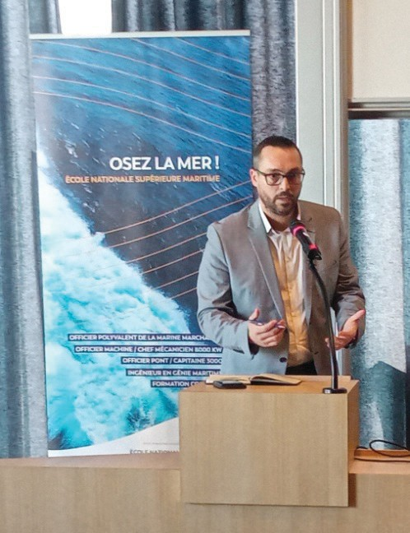
Capt.BLANCHARD-AFCAN President
Of course there is the preparation of the ship, the BMPs, the SSP, and the Hardening Plan. Barbedwire,fireguns,lockeddoors,thecitadel(especiallythecitadel),allofthisisusefulagainst piracy. But in the event of a missile or drone attack, what can we do?

And pirates adapt to the context. For example in Nigeria, pirates have left the EEZ because commercial ships entering it are escorted by a Nigerian navy ship.
The problem is that international law is no longer really respected, not even by States. Examples: a Libyan military ship fires on the OceanViking; the USAsinks boats off the coast of Venezuela.
In addition, conflicts can arise on board with multinational crews. Can we count on the loyaltyofthepeopleonboardwhenoutofacrewof23peoplethereare10nationalities?Thisalso raisestheproblemofthestrategicfleetthatwearetalkingabout:shouldwereducethenumberof nationalities, or even regions on a ship, or even make a selection of the crews to man the ships of the strategic fleet?
The conclusion of this morning went to Vice Admiral Jean HAUSERMANN, IHEDN (Institute of Advanced National Defense Studies):
Outside of DST and straits, the crew has the capacity to avoid geopolitical danger. Should we, from a virtual operations room including MICACenter, insurers, shipowners and charterers, carry out geopolitical routing, as well as meteorological routing? This would require sharing of information and closer collaboration between the merchant navy and the national navy.
With regard to cyber, we must maintain the resilience of ships and be able to navigate in degraded mode. This de facto includes the presence of crew members on board.
Axis2:Tradepoliciesandinternationaltensions
In video, Mr. Jean-Marie PAUGAM, Deputy Director General WTO (World Trade Organization) recalls that maritime routes are the vectors of communications. But the current framework is blocked, which reinforces international tensions.
IntroductionbyMr.YusukeMORI,MasterMariner,PhD,AFNI,DeputyExecutiveDirector IAMU (International Association of Maritime Universities).
TheIAMU,foundedin1999andbringingtogether83membersfrom45differentcountries, participates in the work of the IMO as a Non-Governmental Organization (NGO) in several workinggroups:ontheassistedassessmentsystemforcapacitybuilding,onresearchandacademic publication, on simulator training, and on the review of the STCW Convention.
In1980,weweretalkingaboutacrewof10membersonly,multipurposeseafarers,capable ofworkingondeckandontheengineonthesameday,butwithouttakingintoaccountthefatigue thatsuchsituationscouldgenerateonseafarersonboard.Today,wearetalkingaboutautonomous ships, without crew but with “shore” operators.
In 2000, there was a discussion on the use and role in learning of simulators, mainly the equivalence of simulator hours for obtaining the certificate, and in 2022 there was the same discussion in the United Kingdom, Finland, and elsewhere.
Today, shipping in the future means cleaner ships (propelled by methane, ammonia, or nuclear), and autonomous or remote-controlled ships. Related to the lack of seafarers, it becomes necessary to change skills, education and training, as well as to create regulations surrounding autonomous ships.
The GMP (Global Maritime Professional) initiative, aimed at meeting the needs of the industryinanevolvingeducationalandprofessionalcontext,whilerespondingtotheprofessional development aspirations of seafarers, brings together professors and educators, maritime administrations,shipowners,brokers,navalarchitects,andofficersonboard,i.e.theskillssought currently,butalsointhemediumterm(5to10years)andlongterm(20years),andtoknowhow toteachtheseskills.The“BookofKnowledge”canbedownloadedfromonhttps://iamu-edu.org/ gmp.

ThenMr.FrançoisLAMBERT,ENSM,returnedto3points:
- Humancapital:100%digitalizationofmaritimetransportisafantasy,evensciencefiction. It must be an aid to navigation, and schools must provide training in digitalization, as well as decarbonization.
- Customsduties:we arestillprotected bytheEuropean Union.
- France where there is no real maritime strategy, whereas with Overseas, we hold an importantplacefromthispointofview.TheRIF(secondregister)flagisoneofthemostprominent flagsinEuropewithatonnagedoubledintenyears.Butweseetoomuchintheshortterm.Wesee in5years,whereasweshouldseein30years.Thisisimportantfortrainingcenters.Wemusttrain today according to current needs of course, but also future needs.
Roundtable:NavigatingaWorldofTradeTensions
Moderator:Mr.YannALIX,GeneralDelegateoftheSEFACILfoundation(Laboratoryof prospective ideas on maritime, port and logistics strategies).
AccordingtoMr.DenisTERSEN,IRIS(InstituteofInternationalandStrategicRelations), inthemaritimesector,thereareregularcrisessuchasduringBrexit,andforcertaincountries,itis necessary to control the ports, example of China for the Silk Road, and even imports, example of the taxes put in place by the USA.All that leads to a fragmentation of the world.
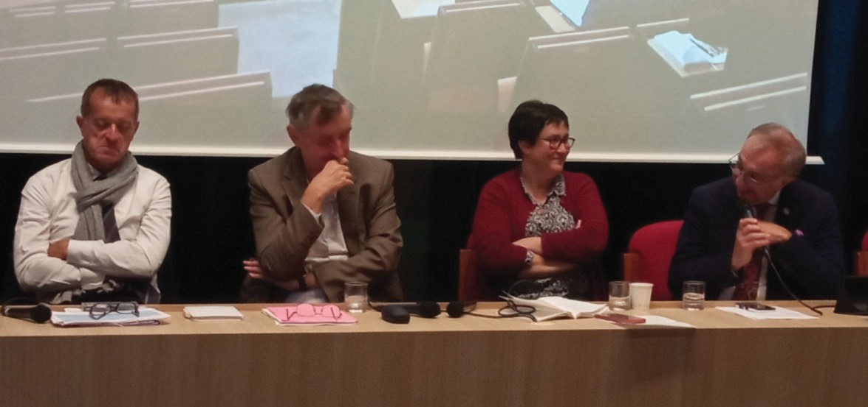
Ms. Charlotte EMLINGER, economist, CEPII (French Center for Study and Research in International Economics) confirms that trade has become a balance of power with unprecedented levelsofcustomsduties,leadingtostronguncertainty.ThestatisticsforChineseexportstotheEU, which until the end of 2024 were at the same level as exports to the USA, show a strong increase totheEU,offsettingasharpdeclinetotheUSA.Andsame,ChinareplacedtheEUontheRussian market following the sanctions.
Thesecondroundtable:LaurentLARTENS–DenisTERSEN– Charlotte EMLINGER – Fulvio CARLINI
For Mr. Laurent MARTENS, General Delegate, Armateurs de France, there are three problems:
- Safety
In 15 years we have gone from a peaceful sea to red zones almost everywhere, hence an additional cost of insurance, but also of fuel (longer route equals more consumption). Security is thefirstdeterminingchoiceforthemaritimeroutestobetaken,hencetheneedforrapprochement with the national navy, and of course with schools so thatsecurityis well understood by allthose involved in maritime transport.

- Sovereignty
Sovereigntydecidesthelevelofsecuritythatwillbeappliedonships.ShipsundertheFrench flagareescorted,evendefended,bytheFrenchnavy.Sovereigntybecomesagainafactorofpower and representation, therefore of national ships, seafarers and shipyards.
- Customsduties
Thecurrentinstabilitydoesnotcreateabrakeonmaritimetransport.Itisathreatbecauseit generates fear among certain national operators such as China and India.
Mr. Fulvio CARLINI, Institute of Chartered Shipbrokers, President of FONASBA (Federation of National Associations of Ship Brokers and Agents), recalls that the profession of shipbroker is a profession of relationships and exchange of information, that it is the permanent dialogue between maritime stakeholders which is the only one capable not of resolving maritime security problems, but of making maritime transport more serene.
At the conclusion of the day, Mr. Justin Hayden MILLER, FIDAL (Business law firm), makesthelinkbetweenthecurrentmaritimesituationandthespaceracetowardstheMoonduring the 1960s. Geopolitics has entered the maritime world, and therefore maritime trade.And as was saidatthestartoftheday,wewillnotgobackbecauseunlikewhathappenedwithspace;itisnot just two States that are in competition, but many more.
Capt.Pierre BLANCHARD
AFCANPresident Capt. Hubert ARDILLON CESMASecretaryGeneral AFCAN Vice president

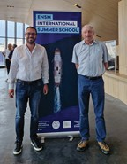
ENSM–1STSUMMERSCHOOL 1-4 JULY 2025, LE HAVRE

The ENSM, center of Le Havre, organized its first summer school from Tuesday July 1 to Friday July 4. Focused on the energy transition, These4daysweredividedintotwoparts,conferencesinthemorningand visitsintheafternoon,inaway“theory”inthemorningand“practice”in the afternoon.
Among the thirty participants, AFCAN was represented, even if sometimes partially, by its president Capt. Pierre BLANCHARD and its vice-president Capt. Hubert ARDILLON.

WelcomebytheDirectorGeneralofENSM,Mr.FrançoisLAMBERT
After a few words of welcome and thanks, he informed that these universities have been in developmentfortwoyears,andareintendedtorenewthemselves,probablybybeingorganizedin the different ENSM sites.
Thestudentsasktobeputintotheconcrete;theseuniversitiesarealsoabitofanattemptto mix conferences and visits, in order to see the interest through feedback to integrate this type of teaching into the student curriculum.

Day1–TuesdayJuly1:Theeco-energytransitioninthemaritime sector
Theme 1: Introduction “Efficient energy transition, where are we? », by Mr. Luc GILLET, engineer, former deputy director of maritime transport at TotalEnergies
Maritime transport plays a strategic role in the global economy. This is more than 80% of thegoodstransportedforaglobalfleetofmorethan100,000ships.Andevenifmaritimetransport mustreduceitsemissions–1billiontonnesofgreenhousegases(GHG)peryear,or2.9%oftotal global emissions – it is also the means with the lowest emissions per tonne transported: 12 times less than road and 70 times less than air transport. But it is also a means very affected by the war and commercial crises of our time.
Emissionsvarydependingonthetypeandsizeofships.Bulkcarriersarethereforeresponsible for23%ofCO2emissionseventhoughtheyrepresent42%oftheworldfleet.Conversely,container ships, 13% of the global fleet, are responsible for 27% of emissions.
The European Union (EU) adopted the “Fit for 55” package in July 2021 to reduce GHG emissions. Four main measures came from this:
–TheETS(EmissionsTradingScheme)directive,inforceonJanuary1,2024forshipsover 5,000 UMS, must be applied progressively (40% in 2024, 70% in 2025, and 100% in 2026).
100% of intra-EU port journeys as well as 50% of journeys to or from an EU port are included.
CH4and N2Owill beincluded from January 2026.
Thetechnicaloperatorofthevesselisresponsibleforpayment,withasanctionintheevent ofnon-compliance(i.e.€100/tonneCO2aswellaspossibilityofbanishmentfromEuropeanports) Plannedemissionquotas:78MtonnesofCO2or8%ofemissionsfrom2024forinternational maritimetransport,withagradualreductionto57Mtonnesin2030.Maritimetransportrepresents around5%ofthetotalEUETSquotas.Theimplementationofthesequotasrepresentsamarketof
4 to 8 billion €/year (at 50 or 100 €/tonne CO2)
–TheFuelEUMaritimeregulation,inforceonJanuary1,2025,aimstoreducetheintensity of greenhouse gas emissions from ships
As for the ETS, there is a progressive reduction in GHG intensity (reference 2020, - 2% in 2025,-6%in2030,-14.5%in2035,-31%in2040,-62%in2045,and-80%in2050,butwitha
calculationbasedontheproductionoffuelatitsconsumption(WelltoWake).
This is the same coverage as for ETS qupotas, i.e. 100% of intra-EU travel and 50% of in/ out EU travel.
Thisregulationfavorstheuseofsyntheticfuels.
It includes a possible pooling mechanism to ensure compliance; the technical operator is responsible for this. Financial sanctions are planned based on the cost of the low-carbon fuel that will be used, knowing that 1st generation biofuels are excluded.
Shore power in major ports for container ships and passenger ships will be mandatory from
2030.
- TheAFIRregulation(AlternativeFuelsInfrastructureRegulation)-Deploymentof
infrastructure for alternative fuels, in force inApril 2024
ThemainEuropeanportsmustbeequippedbeforeJanuary1,2030withshorepowertomeet thedemandofaround90%ofcontainershipsandpassengershipscalling,shorepowerwhichmust also serve the main river ports.
- Thedirectiveonenergytaxation:endofthetaxexemptionformarinefuels,directivestill under discussion.
This is the proposal for a minimum level of taxes to encourage the use of sustainable fuels, with a 10-year exemption regime for sustainable fuels.

Note:Asa tax, thisdirective requiresunanimousapproval of Member Statesto be adopted. The IMO revised its decarbonization strategy in July 2023. From a 40% reduction in CO2 emissionsin2030(comparedto2008emissions),reductionsshouldnowbe20%in2030and70%
in 2040, still compared to 2008 emissions, but for overall GHG emissions rather than CO2 only. New regulatory provisions were approved at MEPC83 inApril 2025, for ships over 5,000
UMS.
GHGfuelintensitylimitsforenergyusedonboardaresetattwolevels:a“baselinetarget” levelanda“directcompliance”level.AreductioninGHGfuelintensityisplannedovertimeand penalties feed an international fund.
Compared to a reference level of 93.3 gCO2eq/MJ (fleet average in 2008), there will be a financialrewardforshipsusingfuelwithzeroornear-zeroGHGemissionsbelow19gCO2eq/MJ, a threshold which will be lowered to 14 gCO2eq/MJ on January 1, 2035.
Note: gCO2eq/MJ: gram of CO2 equivalent per megajoule of energy
However, to come into force, these new provisions will have to be adopted during the next MSCinOctober2025forapplicationin2028attheearliest,andmanypointsrequireclarification. The industry is not short of initiatives. In 2025, a study by the Global Center for Maritime Decarbonizationshowsthat70%ofshippingcompanieshavedecarbonizationpolicies.Numerous R&Dcentershavebeensetupforthispurpose,including“coalitions”ofindustrialpartnerswhose
aimisto work together and exchange information.
Amongthetechnicalimprovementsinenergyefficiencywecannote:
  - Hydrodynamics: optimization of hull shapes (such as wind deflectors) through the use of digital twins as well as hull appendages such as new bulb designs, propeller nozzles, pre-swirl stators, fins on propeller nuts, rudder bulbs.
  - Theinjection ofair bubblesunder the keelfor aperformance gaingreater than 5%.
  - Theuse ofnewantifouling paints
  - Improved engine consumption, electronic injection control, and new exhaust gas heat recovery systems.
  - Windassistanceindifferentforms Other improvements:
  - Optimizationofthecrossing,analysisofmeteorologicaldataandonlineship-to-shore
digitalexchangesbya
- Optimizationofconsumptiononagivenroutebycontinuousspeed adjustment
- Optimization of weather routing with multi criteria wind, swell, currents, to minimize consumption,securearrivaldates,limitrisks(lossofcontainers,movementofgoods,etc.),thanks to digital twins currently being developed Weather routing is widely used for ships with sail propulsion assistance
- Reduction ofwaitingtimesat theport(Justin timeArrival), idealsolutionbutdifficultto
implement
  - Installationinportsandterminalsofthepossibilityofshoresideelectricalconnection
  - Installedcarbonrecovery systemsbeing installedon boardand stackedin ports
  - Thedevelopmentofbiofuels,evenifthequantitiesremainlimitedandmarginal,especially for the navy in competition on this subject with other means of transport (road and air). Themainalternativelow-carbonfuelssubjecttoR&Danddevelopmentprojectsareammonia(NH3), hydrogen(H2)andmethanol(CH3OH),butwithvolumeratiosforthesameenergythatarelargely deficits and increased safety and toxicity risks.
  - Electric,hybridor100%batterypropulsion,asolutionmainlydesignedforshortdistances

- Fuelcellswith2typesofcells:
- PEM (Proton Exchange Membrane Cell): “low temperature” 80°C, running on hydrogen with a high degree of purity, more compact, less heavy, and resistant to transient cycles
- SOFC (Solid Oxide Fuel Cell): “high temperature” 800°C and producing usable heat on board, operating with numerous fuels: LNG, LPG, and Hydrogen.
- Nuclear propulsion: mainly in military navies and icebreakers, but many projects are in development for merchant navy.
Where are we?
In January 2025, ships in service using conventional fuel oil represent 92% of the global fleet and 47% of the fleet on order. Ships using alternative fuels (53%) are therefore becoming moreimportantforthefirsttime,withordersofcourse,mainlyLNG(38%),methanol(12%),LPG (2%), ammonia (0.9%) and hydrogen (0.2%) being still anecdotal.
Theme 2: Public policies for a sustainable merchant marine, by Mr. Hervé THOMAS, Directorate General of MaritimeAffairs, Fisheries andAquaculture (DGAMPA)
Thereareseveralelementsof supportfortheFrench fleet:
- Fiscal support: the tonnage tax, even if currently under attack in the NationalAssembly, isthemainsupportsystemforboatownerswithasignificantbenefitfortheflag;taxdeductibility (art. 39c of the tax code); and state credits.
- Budgetarysupport:exemptionfromemployercontributions,whicherasesthedifferences in cost of French ships compared to other flags.
- “Security”support:Frenchshipsbenefitfromtheprotectionofthenational(orEuropean)
navy.
- “Training”support:Frenchsailorsarestillinhighdemand(benefitofversatility),which
also leads to an increase in ships under the French flag. From 2013 to 2023 there are 43% more ships under the French flag.
- “Human”support:thefightagainstsocial dumping.
Activity1:Hydrogenbargeprojectmanagement,byMr.Louis-MarieROUXEL, Technical Director SOGESTRAN Group
SOGESTRAN is the leading French river shipowner, also one of the leaders in maritime with international influence. SOGESTRAN has more than 170 river units and 20 owned vessels.
To reduce the environmental footprint of activities, it is necessary to optimize energy efficiencyinordertolimititsimpact,chooseenergysourceswithlowcarbonintensity,andoperate with greater sobriety.
For the river, this means using bio-fuels, e-fuels, hydrogen, batteries, and of course electricityatthedock.Itisalsoanoptimizationofthefillingandspeedofbargesandriverboats, and consequently of the training of crews.
Regarding maritime, in addition to river elements, there is the use of sail propulsion and weather routing.
SOGESTRANisinvolvedinseveralprojects:
- TheZULU6H2 project:hydrogen-powered barge
Hydrogen,thesmallestofthechemicalelements,isveryabundant(inwater,hydrocarbons, and sugar, etc.), but in dihydrogen form (H2), it is only present in trace amounts.
It must therefore be produced, and there are two means of production: by steam reforming, more than 90% of world production, but a significant CO2 emitter; by electrolysis of water, still an anecdotal solution, but making it possible to make hydrogen a zero-emission fuel when the electricity used for production is from a renewable source.

Then there is storage, the main difficulty with hydrogen. The energy density of H2 is approximately2.5timesgreaterinmassthanotherconventionalfuels,butintermsofvolume,H2 requires 4.5 times more space for liquid and almost 7 times more space for tablets at 7 bars.
  - ENERGYSTOCKHOLM:largestLNGtankerinEurope(8x1,000m3)
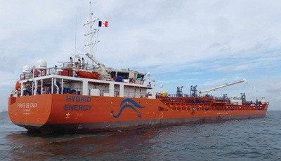
  - POINTEDECAUX:hybriddiesel/batterypropulsion,4,700MTdeadweightwithazimuth thruster, shore connection, 15kW solar panels, 312kWH battery pack
PartnershipwithWISAMO(Michelin) onthe developmentof thesailing industry
Activity 2: Visit to the hydrogen barge, by Mr. Louis-Marie ROUXEL, Technical Director SOGESTRAN Group
ThenwewenttotheSOGESTRANsitetovisittheZULUhydrogen barge
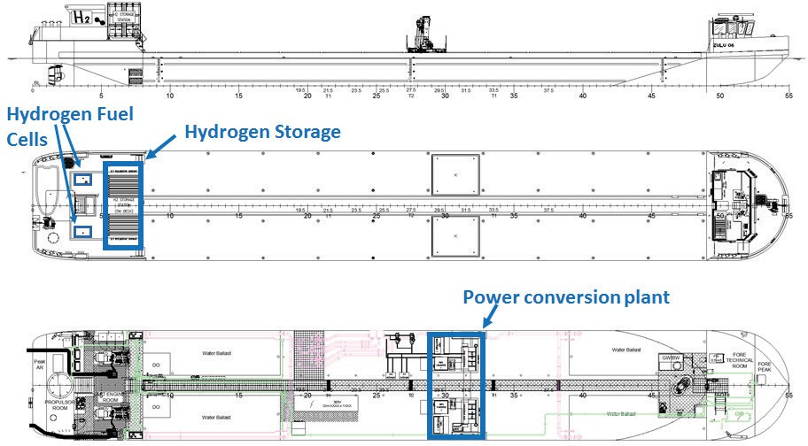
This is a barge intended to supply the Parisian terminals with the goods requested from the port of Gennevilliers, which is supplied by barges from Le Havre or Rouen.
This barge can only be loaded on its deck, by pallets. It is equipped with a crane for self- unloading, and runs on fuel cells.
The fuel cell is an electrochemical system in which an electric current is formed due to the oxidationononeelectrodeofareducingfuel,associatedwiththereductionontheotherelectrode of an oxidant. On the ZULU, hydrogen acts as a “reducer” and oxygen as an “oxidizer”.

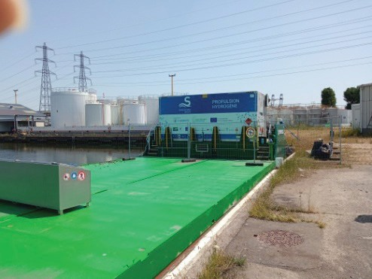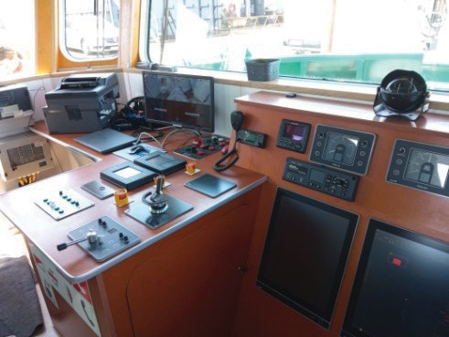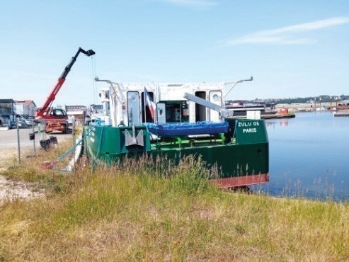

chain
Day2–WednesdayJuly2:Theeco-energytransitioninthemaritimesector:thevalue

Theme:Settingupandfinancinglow-carbonprojects,byMr.AlanSYMONEAUX,

DeputyDirectorofShipSafetyandEnergyTransition,DGAMPA
Whatarethedecarbonizationleversidentified:
Regulatory,forsafetyreasons(batteries,ammonia,newmaterialsetc.);
- Energy, because resources are limited given the significant needs for the production ofalternative fuels;
- Technological,duetothecomplexityofthesolutionsremainingtobedevelopedormade reliable
- Financial,becausedecarbonizedsolutionswillgenerallybemoreexpensiveininvestment (CAPEX) and sometimes in operation (OPEX);
A fair composition of these levers must therefore be decided, based on the characteristicsof the ships (size, power and operational needs), but also based on the associated technological, regulatory, financial and energy constraints.
The renewal of 90% of the existing commercial fleet under the French flag in the next 10 years is estimated between 14 and 18 billion euros depending on the technologies used (1.5-2 billion/year), and between 75 and 110 billion euros for French shipowners for the period 2023- 2050, not including operational costs.
The financing supporting the decarbonization of the maritime sector is French public, co- pilotedbytheDGAMPA,Europeanpublicfollowed,disseminated,andsometimesinfluencedby the DGAMPA, and French private followed by the DGAMPA.
National levers:
- France 2030
The entry point for the maritime sector to the France 2030 funds is through the Orientation and Research Council for Marine Industrialists (CORIMER), dependent on the Strategic Committee for the Maritime Industrial Sector.
During the CORIMER 2021/2022 call for expressions of interest (AMI), 21 projects (including18linkedtothethemeofshipandEMRdecarbonization)weresubmittedfor a total aid amount of approximately €53.2 million.AMI CORIMER 2023 saw 13 winning projects(including8projectslinkedtothedecarbonizationofships),foranamountofaidof
€46M.In 2024, noAMICORIMER hasbeen published.
In 2025, for the first time, a call for projects (AAP) dedicated to the decarbonization of the maritime sector was published: the Low Carbon ShipAAP.
France 2030 mobilizes 54 billion euros, this plan should make it possible to catch up with French industrial delays, invest massively in innovative technologies and even support the ecological transition.
- Greenover-depreciation

Tax deduction mechanism to encourage green investments, including low-carbon investments, in maritime transport. This system benefits shipowners, who invest in ecological modes of propulsion:itallowssuchequipmenttobedepreciatedataratehigherthanthatofcommon law,aratemodulatedaccordingtotheenvironmentalperformanceofthegreenequipment(s) installed on the ship, and their use (main propulsion or ancillary equipment).
Thismechanismconcernsnewconstructionsbutalsoretrofitoperations.Itwasputinplace in 2019 then revised in 2024 to comply with new European rules, it makes it possible to supporttheecologicaltransitionofthemaritimesectorthankstoataxadvantage.The2024 reformhassignificantlyreducedthebaseofeligibleinvestmentsbydefactoreservingthem for entirely decarbonized propulsion. Scheduled to end at the end of 2024, it was extended until the end of 2027 by the finance law for 2025
  - ETSrevenues
Since January 1, 2024, maritime transport has been integrated into the European carbon market(ETS),requiringcompaniestoreturncarbonquotaseachyearcorrespondingtotheir greenhouse gas emissions from the previous year.
The Interministerial Committee for the Sea (CIMer) has decided that part of the revenue generated by the product of the maritime ETS and returned to the State will be mobilized forthedecarbonizationofthemaritimesector,uptotheamountscollectedforthepastyear. Thus, for 2026, 90 million euros could be recovered.
Governance involving stakeholders in the sector will be put in place to identify the decarbonization actions to be prioritized, based on the maritime decarbonization roadmap, as well as to define the most appropriate priorities and financing methods.
The decarbonization roadmap meets the obligation of Article 301 of the Climate and Resilience Law (2021), it is co-led by DGAMPA & French Maritme Cluster (CMF), and relies on a “group of recognized experts from the sector and the administration.
European levers:
Funding by call for projects exists directly at the European level, it is the Innovation Fund whichcanrepresentavolumeof1,050millionquotas,or94.5billioneurosovertheperiod2021- 2030, as well as funding from Horizon Europe, FEAMPA (European fund for maritime affairs, fisheries and aquaculture), and FEDER (European regional development fund).
International levers:
Atthe international level,there isthe IMOagreement on carbon pricing.
OnApril11,2025,the175membercountriesoftheIMOagreedonacarbonpricing mechanism, to encourage shipowners to reduce greenhouse gas emissions from their ships. This measureaimsto achieve theobjective of carbon neutrality inthe maritime sector “around” 2050.
From2028,largeshipswillhavetousecleanerfuelsorpaypenalties.AccordingtoanIMO estimate, the system will bring in between $11 and $13 billion per year.
Themoneythuscollectedwillbereinvestedinzeroornear-zeroemissiontechnologies or fuels and will also be used to financially support developing countries as part of the energy transition in maritime transport in order to offset the increase in the price of food due to rising transport costs.
Shipsusinglow-carbonfuels(e-fuelsorbiofuels)receivearewardintheformofcompliance units and financial payment, amount remaining to be determined.
Shipsusingalternativefuels(themajorityofcases)mustpayafixedcontribution,setat
$100/ton of GHG.
Finally,shipsusingthemostemittingfuels(fossils)mustpayadissuasivepenaltysetat

$380/ton of GHG. But they can do this by purchasing compliance units from over-compliant vessels to at least partially compensate for their deficit units.
Private levers:
Finallythereare privatelevers, example“the CMACGMfunds”
In November 2022, CMA-CGM announced the creation of a €200M fund dedicated to the decarbonizationofmerchantshipsandfishingvessels,afundofficiallylaunchedonApril25,2024 with 20 million grants for the Endowment Fund for the decarbonization of fishing
Day3–ThursdayJuly3:Maritimeenergyefficiencyplanning
Theme1:PresentationofMaritimeRenewableEnergy(MRE)andconflictsofuse,by Mr. Lucas LEPERLIER, Head of the maritime policy coordination mission, Inter-regional Directorate East Channel – North Sea
Elementsofawindturbine:
- Thefoundation to attach theentire structure to the seabed
- Themastwhichsupportsthenacelleandthebladesaswellastheimportantelectrical
elements
- Thenacellewhichcontainstheelectricityproductiongenerator
- The rotor, including the hub and the blades. It is the rotating part of the wind turbine which allows the transformation of the kinetic energy of the wind into mechanical energy, then transmitted to the generator.
- All for a total height of almost 270m high (VestasV236-15.0 MWtype wind turbine) for a rotation diameter of 240 meters.
- Plus electrical cables used to connect the wind turbines to each other as well as to the electrical connection station at sea.
- Twodifferenttechniquesbetweeninstalledandfloatingwindturbines,wewilluseinstalled wind turbines for depths of less than 50 meters and the floating wind turbine technique connected by cables and anchors for depths greater than 50 meters.
TheMulti-yearEnergyPlanningProjectisbased on:
- Nuclear:EPR 2construction programfor aminimum productionlevel of 300TWh/year
- Biofuels:40% increasein theiruse by2030 (v/s2019)
- Hydroelectricity: 2.8GWincrease in current capacity
- Photovoltaics:multiplicationby 5by 2035(v/s2023)
- Hydrogen:reach 8 GWin 2035
- Renewableand recovered heat: multiply consumptionby 2 between 2022 and 2035
- Onshorewind power: reach 1.5 GWof additional capacity per year
- Biogas:multiply itsproduction by5 by 2035
- Offshorewindpower:reach18GWofproductionin2035,or10%ofcarbon-freeelectricity production.
Offshore wind power is therefore an essential component of the energy transition, and destined to become the primary source of electricity in 2050.
Amongthe18objectivesoftheNationalStrategyfortheSeaandtheCoast(SNML)–(decree of June 10, 2024), objective no. 13 is written as follows: Develop renewable marine energies to contribute to carbon neutrality 2050 with a target of 18GW allocated by 2033
Likewise,Directive2008/56/ECoftheEuropeanParliamentandoftheEuropeanCouncilof June 17, 2008 establishes a framework for community action in the field of policy for the marine environment.

MapofvocationsoftheChannel-Eastern NorthSeacoastline (fromNEto SW):
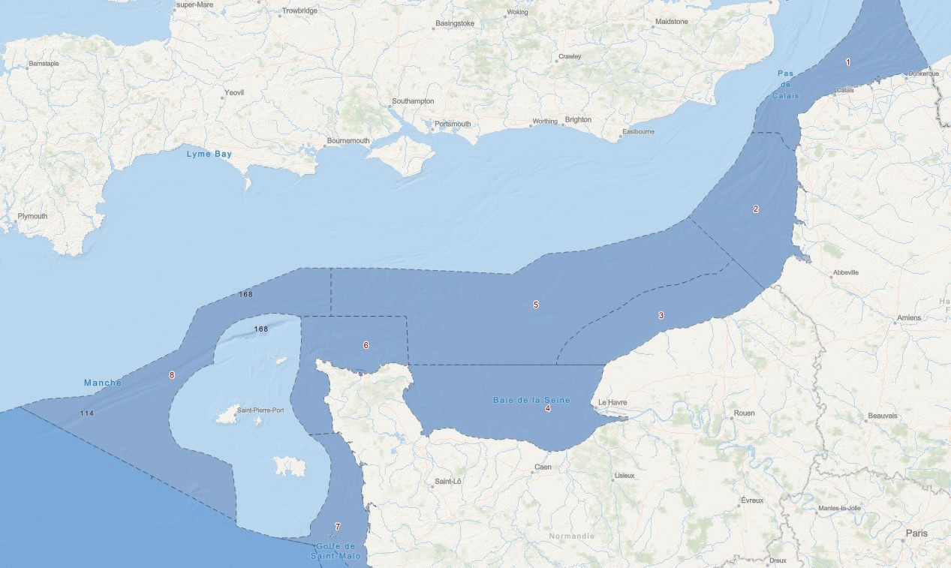
1:CapesandStraitofPasdeCalais(DoverStrait)
Predominance of maritime navigation, maritime security issues and port and MRE infrastructure.Needtomaintainmaritimefishingactivity,theaquaculturepotentialoftheareaas wellasmarineaggregates,whileallowingthereceptionofgrowingtouristactivities.Preservation of migratory corridors and remarkable habitats.
2:PicardyestuariesandOpalSea
Predominance of maritime navigation and maritime security issues.
Zonefordevelopingknowledgeofmarineheritage,protectionandsustainabledevelopment of the marine environment (fishing) and sustainable marine aquaculture and associated port activities, coastal tourism, preservation of functional fishing and aggregate zones).
3:Côte d’Albâtre anditsopen spaces
Zone of reinforcement of the potential of renewable marine energies, sustainable fishing activities and extraction of marine aggregates while respecting fishing functional zones.
4: Bay of Seine
Zone of strengthening the cohabitation of uses in a context of present or future multi- activities(marineaggregates,fishing,aquaculture,marinerenewableenergies,touristattractions, port infrastructures, major industrial and defense) and strong estuarine ecological issues (nursery grounds, spawning grounds, nesting sites, etc.).
5:Widebayofthe Seine
Predominance of maritime navigation and maritime security issues.
Development zone for MRE and marine aggregates, in coexistence with existing maritime activities,includingfishinganddefense,andthespecificneedforprotectionofmarine mammals.
6: North Cotentin
Area with high potential for sustainable development of current or emerging maritime activities(sustainablefishingandmarineaquaculture,energyproductionbytidalturbines,

shipbuilding, military activities, coastal tourism, etc.).
7:WestCotentin–BayofMontSaint-Michel
Zonereconcilingitsvocationforshellfishfarmingandmaritimefishingontheonehandwith itstouristattractiveness,therichnessofitsnaturalheritageanditsmarineecosystemsontheother hand.
8:WestChannelofftheChannelIslands
Predominanceofmaritimenavigationandmaritimesecurityissuesincoexistenceprimarily with sustainable professional fishing activities aimed at developing renewable marine energies.
Conservationareaformammalsandseabirds. State of the art of offshore wind power:
Firstcallsfortendersin2011and2013forcommissioningfrom2022:3GW Third call for tenders awarded in 2019
Sincetheendof2020,6callfortenderprocedureslaunchedfor3.25GWincluding750MW of floating projects
Thatis,10.4GWinstalled,allocatedorintheprocessofbeingallocated,thereremains15.5 GWto be identified and allocated in the next 10 years, and 19.1 GWto be identified and put into service by 2050.
Four simultaneous public debates were held from November 2023 to April 2024, i.e. 5 months of debates on the country’s 4 maritime facades with more than 21,000 participants.
Thesedebatesraisedkeyissues:
- Accesstoinformationandknowledgeneeds
- Mitigation and adaptation to climate change with regard to the objective of achieving good ecological status of marine waters
- Humanactivitiesinthefaceofthesechanges
- Conditionsfordevelopingoffshorewindpowerwithregardtoenvironmental protection
- Developmentof strong protection zones
- Governanceof my time planning
Example:takingintoaccountthetrafficoftheSeineports:
Lessonsfromthedebate:maritimesecurityisamajorissue,needtomaintaineasyaccessto the port of Fécamp
Taken into account: continuation of traffic organization work in the North Bay of Seine,conservation of an access corridor to the port of Fécamp
FocusonaccesstotheportofFécamp:
Definedwithregardtotrafficissues(sustainedfishingactivity,Dieppe/NewhavenFerry line), landscape (visibility cone from Étretat) and aggregate (possible access and extensions).
Theme 2: Economics of MRE challenges: Presentation of the activity of the Siemens Gamesa factory, by Mr. Ivain BRIAND, Deputy Directorof port operations at the Siemens Gamesa factory in Le Havre
Gamesahasmorethan5,000offshorewindturbinesinstalledinvariousEuropeancountries, USAandAsia. In Europe, this represents 28GW installed and 20GW in the future, or 31 million European households.
Gamesa has been in partnership with Haropa since 2020 for a production site for turbines and wind turbine blades. An expansion of the site is underway for the production of 115 meter bladesintendedfortheEuropeanmarket.ThecurrentB81blades,81meterslong,6metershigh

and 4 meters in diameter, weigh 34 tonnes per blade. Blade production uses “Integral Blade” technology.Agondola,measuring20meterslong,10metershighand8meterswide,weighs430 tonnes.Asforthetowersections,for36meterslongand6metersindiameter,theweightofeach section is 130 tonnes.
To make a blade, the lower mold is lined with lengths of fiberglass then filled with male moldstoformit,thenthesamefortheupperpart.Thensealing,vacuumdrawingandinjectionof epoxy resin into the mold. Then cooling the assembly for 5 to 6 hours, inspection and geometric repairtoobtainthebestprofileandpaintingandfixingofaerodynamicappendageswhichreduce noise and improve air flow.
Tomanufactureablade,ittakes10daysand15daysfora nacelle.
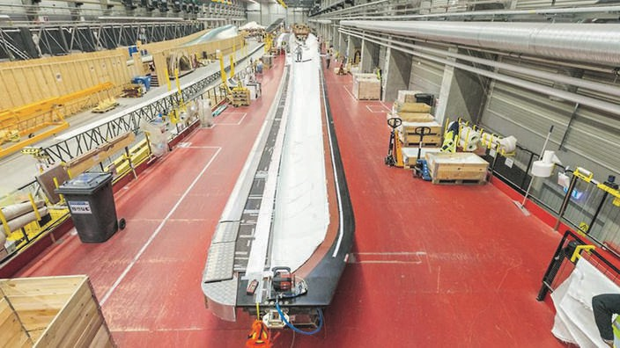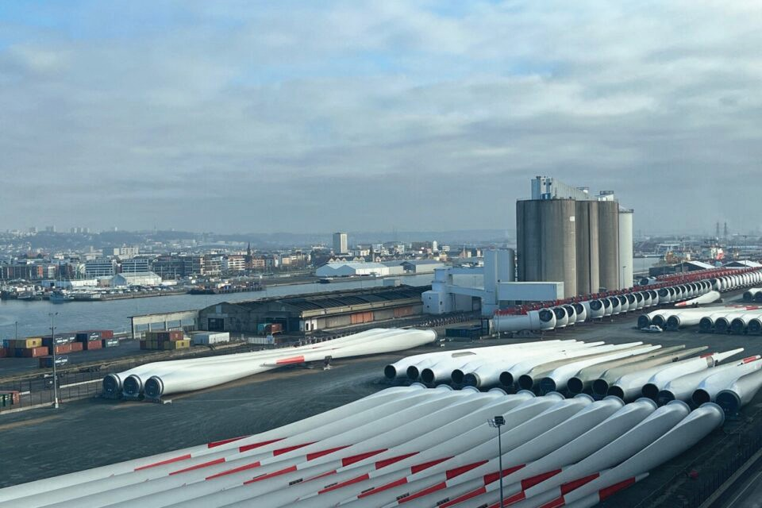
The storage of blades, 140 blades in the main area and 200 on the Bougainville quay, and nacellesrepresentaverylargesurfaceareaintheport.Thisstoragemustalsohavequayaccessfor ships loading in LoLo (lift-on, lift-off) and RoRo (roll-on, roll-off).
Thereisthereforepre-assembly(towers,pullingofHVcables,electricaltests)beforeloading onto a jack-up ship. Assembly at the electricity production site is done in less than 24 hours. Gamesa also ensures commissioning activities before delivery.
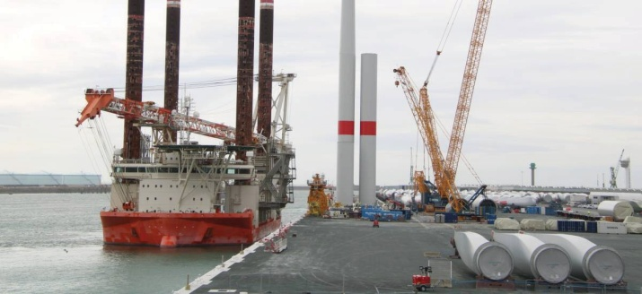
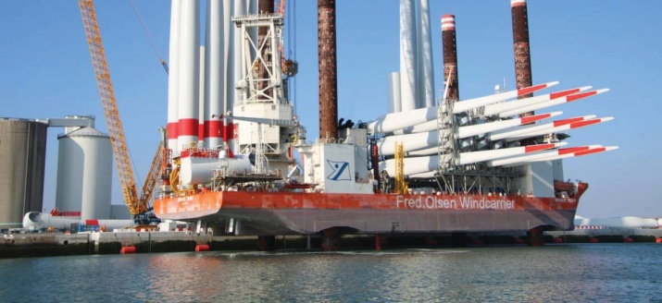
Activity:VisittotheFécampwindfarm
TheFécampwindfarm,71windturbinesforaround500MW,islocatedbetween13and24 kmfromthecoast.Itcoversanareaof60km2.Thewindturbinesare1kmapartfromeachother, or about 5 times the total height of a wind turbine (with one blade at the top)
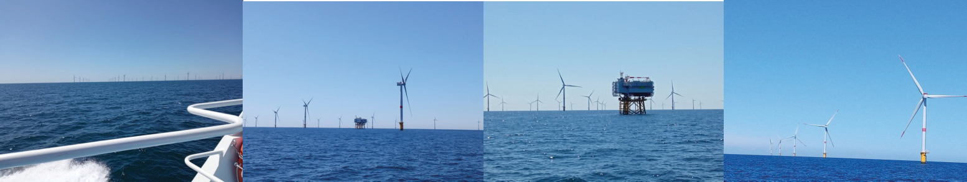

There has been authorization for navigation in the park since June 3, 2024, with some navigation safety rules: speed in the area limited to 12 knots, vessels must have an overall length of less than 25 meters, ban on anchoring, it is prohibited to approach less than 50 meters from a wind turbine and less than 200 meters from the electrical substation. Underwater navigation is also prohibited as are towed (water skiing) or aero-towed (kitesurfing) activities.AnAIS beacon is mandatory.
Ontheotherhand,professionalfishingandrecreationalfishingareauthorized,undercertain conditions.
Day 4 – Friday July 4: Sailing propulsion
Theme1:Sailingpropulsion:Frenchtechnicalexpertise,byMr.PierreCHIFFOLLEAU, teacher at ENSM
Currentlytherearesome120WASP(WindAssistedShipPropulsion)atsea,andaround200 on order.
There are two families of wind profiles: passive profiles which generate an aerodynamic force by the sole movement of air on their surface, and active profiles which require the use of auxiliary energy (rotors and aspirated profiles).
Thinpassiveprofile:thegainwillbeonthesailcurvatureadjustment(differentfromshock/ tuck the sail), for a gain of 1.5 knots on average.
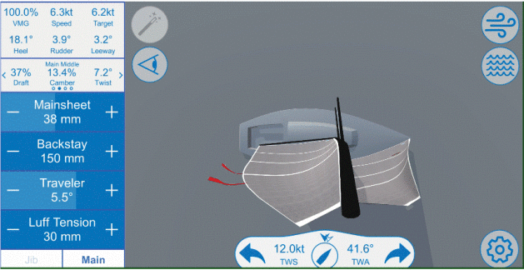
Thickpassiveprofile:rigidwingmasttype,themainfaultofwhichistogivedrift(15to18 degrees on the Canopée).
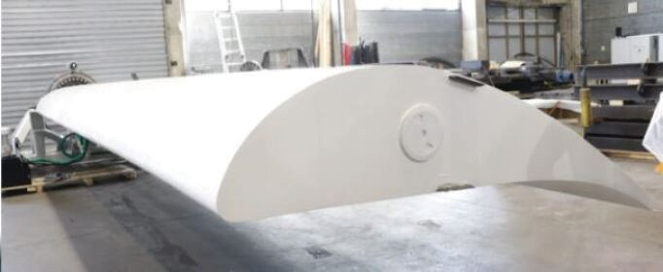
The rotor masts are equipped with a permanently rotating fan, which allows them to move upto20degreesfromthewind.Therotorsrotateinbothdirections,withthedirectionofrotation changing depending on where the wind is coming from. On the Pelican, this gave an 8% gain in fuel consumption. This profile is well suited to vessels with open decks, such as oil tankers and bulkcarriers.Ontheotherhand,thisgeneratesaverylargedrift,andthereforerequiresnavigation officers to determine the useful drift based on the weather maps studied.

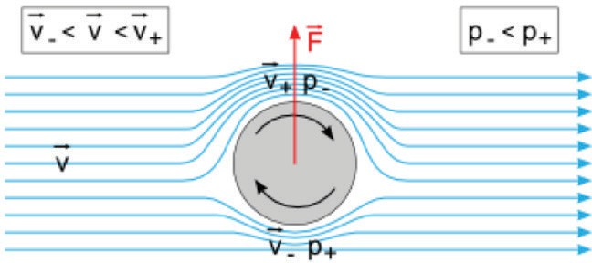
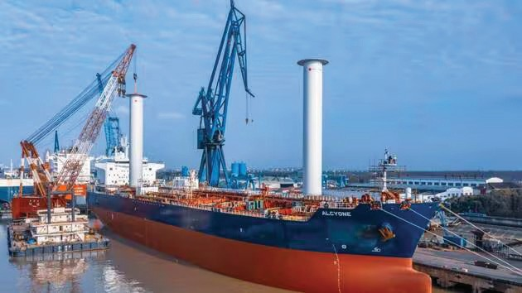
The kites, complicated to implement, and especially to return, on the City of Bordeaux 4 people were needed for these maneuvers, therefore a problem of profitability. On the other hand, the advantage of the kite is that it does not create a zone of no visibility.
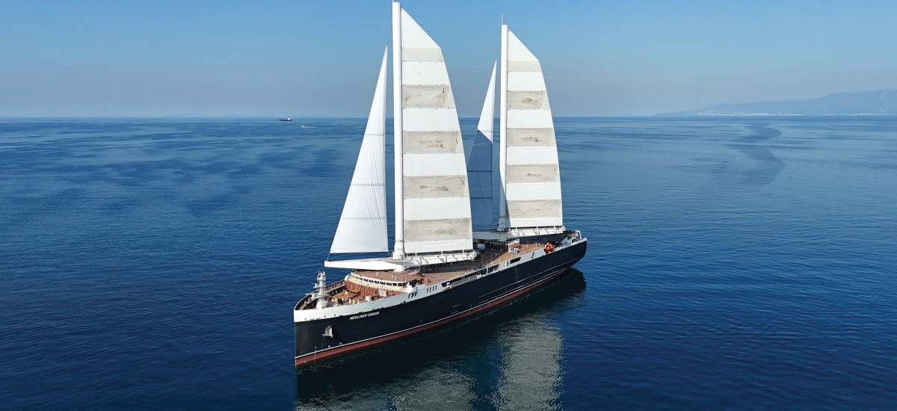
OntheNeolinerOrigin,itisabalestranrig:alargeboomthatpivots.Butthesailsarerigid, and there is therefore no possibility of reefing.
OntheCanopée, themastsarefoldable, andthefabric sailsfold likean accordion.
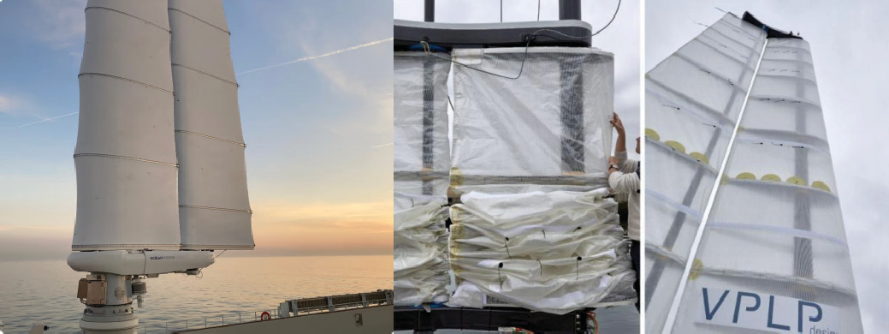
Inflatablesails–WisamoMichelintype

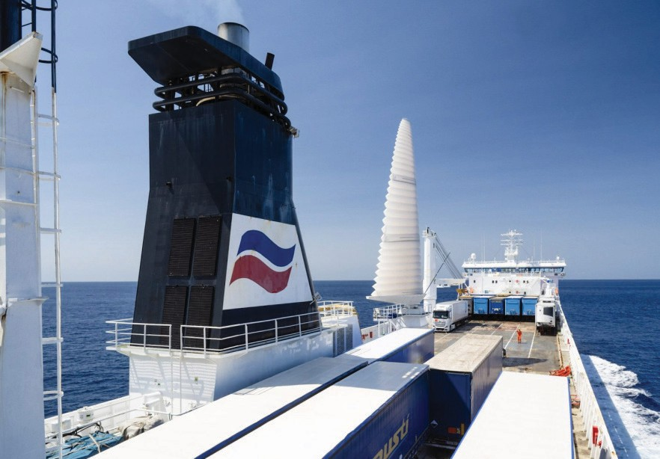
Weatherrouting:
VeryimportantandimpactfulpointforWASPs.Theobjectivesare:
- Maintainsufficientclearunderkeel
- Limittheforcescausedbythe stateofthe seaonthe shipandthe cargo
- Transitthroughaspecificpoint(DSTforexample)
- Avoidcertainareas(piracyforexample)
- Completeajourneyasquicklyaspossible(foroffshoreracing)
- Reduce consumption
- Agree with terrestriallogistics
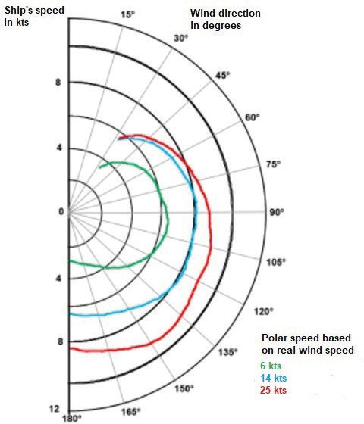
Polarspeedofanexclusivelywind-poweredship
Regulatorydevelopmentstobe expected?
- Integratea hybrid ship class?
- Colreg:new rules?
- NavigationinTSS:specificstandards? Training at ENSM:
ENSMparticipatesjointlywithENSTAandtheDefenseInnovationAgencyandin
partnershipwiththeNavalAcademyintheSOMOSproject:Modularsolverand3-Dsimulatorfor wind-powered ships.

Creation of a free and modern online training module (Digi4mer) including:
  - Windpropulsion
  - Fluid mechanics
  - Tallships
  - Aerodynamics
  - Mastsand rigging
  - Control of aerial profiles
  - Hydrodynamics
  - Currentology
  - Meteorology
Thismoduleisintendedforseagoingpersonnelinvolvedinoperatingvesselswithauxiliary or main sail propulsion. For duration of 35 hours, it allows you to be trained in:
  - Masteryofthedifferenttechnologiesdeveloped(driving,adjustmentandmaintenance)
  - Apprehensionofnewriskslinkedtotheuseofverylargeriggingand sails
  - Routeplanning, optimization of the performanceprovided by the sail propulsion system
Theme2:Economicchallengesofsailboatconstruction,byMr.GuillaumeLEGRAND, president and co-founder of TOWT
ForMr.LEGRAND,shippingwillnotbeabletodecarbonize,theholdsareveryinexpensive, andsoarethesailors.TOWTofferscompletelycarbon-freefreighttransport,whichhasanimpact onthecostofcharteringbecauseitisnotdependentonthepriceofoil,thereforecontractscanbe concluded with long-term visibility.
TOWT, currently there are 2 ships under the French flag and 6 on order which will join the fleetby2028,assuchTOWT(DoC)andtheships(SMC)areISMcertified.Thecompanyemploys 32sailors,8percrew,so16includingthoseonleave,notethatwomenrepresent45%ofthecrew.
Largeshipsarenotcompatiblewithdecarbonization,whichiswhyTOWThaslimiteditself to ships of 81.6 m in length (92 m overall) for a capacity of 1,200 tonnes, a draft of 5.5 m and an air draft of 64 m, and an average speed of 10 knots.
Thestructureoftheshipsfavorssailingonallpointsofsail,withautomatedsailadjustment.
Themastsare carbon.And there isalso an intelligentballast system toadjust trim and heel.
The cargo is loaded, by the two cranes on board, in pallets and distributed in 6 holds on 3 decks,withthepossibilityofsegregatingthedifferentgoodstransported,maintainingthemat a stable temperature and humidity level thanks to IoT sensors installed in all the holds (the IoT sensor is an electronic device capable of detecting and measuring physical and environmental variables such as temperature, humidity, gas, etc.).
Sailingshipsrepresentanintelligentsolutionfordecarbonizingmaritimetransport:lessthan 2gofCO2perton.km,ittakesaround1/3ofthelifeofashiptoamortizeconstructionemissions. Duringitsoperation,asailingshiphasalimitednoiseimpactandanabsenceoftoxicdischarges.
Activity:TallShipRace
In July, Le Havre was the starting point for “The Tall Ship Races 2025”, an international sailboat race. The city organized a festive event entitled “Les Grandes Voiles du Havre” from July 4 to 7. Participants in the ENSM Summer Universities could board a sailboat and sail in the afternoon in the port of Le Havre.
Capt.Pierre BLANCHARD
AFCANPresident Capt. HubertARDILLON
CESMASecretaryGeneral–AFCANVice-president

FROM UPKCG NEWBOARDELECTED
TheShipmaster’sAssociationofMontenegro(UPKCG)hasreneweditsBoardintheelection of 5 Captains under the presidency of Capt. Ivica FAZO. UPKCG is hoping to host a CESMA AGA in near future.
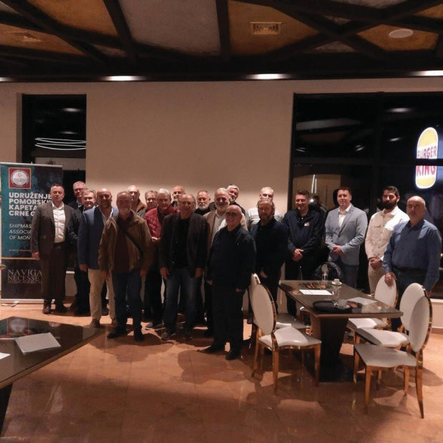
Photo of theAssembly
Capt.IvicaFazo PresidentUPKCG

FROM ZHUPK
AGAATTISNO,MURTERON6THMARCH2026
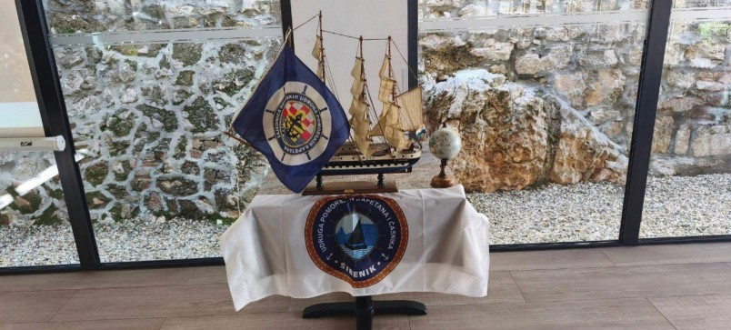
Assembly Proceedings
Before the start of the Assembly, the President of the Šibenik Association, Capt. Branko Skorić,addressedthegatheringandbrieflyintroducedhisactivitiesandassociates.Heapologized that he had to leave theAssembly because he needed to carry out pilotage for a ship entering the port, and that he would return.He was replaced by Secretary Capt. Jurat.

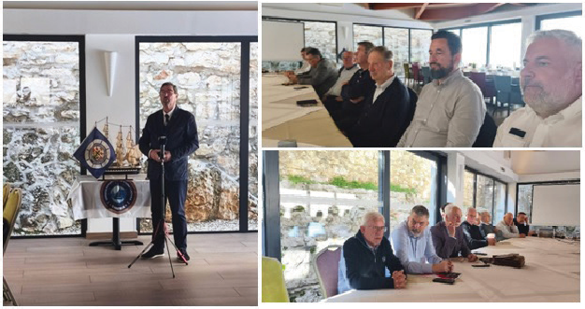
DuetotheillnessofthePresidentoftheKostrenaAssociation,hewasreplacedbyhisdeputy, Capt. Vičević, who proposed that the working bodies of theAssembly be elected as follows:
  - Capt.Vrdoljak,SecretaryoftheZHUPKAssociation
  - Capt.Vičević,DeputyPresidentoftheKostrenaAssociation
  - Capt. Jurat, Secretaryof the ŠibenikAssociation
Theproposedagendawasput toavote;there werenoproposalsfor amendments.
Basedonthesignedattendancelist,itwasestablishedthatoutof20delegates,16were present.It was confirmed that theAssembly had a valid quorum.
Verification of the minutes from the previousAssembly — it was decided that they did not need to be read, as all participants had received the minutes after the session in Kraljevica.
Theproposal wasunanimously adopted.
ThereportonactivitiesbetweensessionswaspresentedbyCapt.Vičevićonbehalfoftheill President of the Kostrena Association.
Itwasproposedthatdiscussionsbepostponedto“Miscellaneous.” The proposal was unanimously adopted.
ThefinancialreportwaspresentedbySecretaryCapt.Vrdoljak.Sincethereporthadalready been sent to theAssociations by email, there were no comments.
Thefinancialreportwasputtoavoteandunanimously adopted.
Proposal to dismiss three members of the ZHUPK Presidency of the KostrenaAssociation, as their one-year mandate had expired, and to elect new members from the Šibenik Captains Association.The proposal was unanimously adopted.
As there was a majority quorum for Statute changes, it was proposed to include a new address for ZHUPK in the Statute:
Grgura Mrganića Street 9, 23000 Zadar Theproposal wasunanimously adopted.
BasedonArticle29oftheStatuteSecretaryCaptainVrdoljakopenedtheconstitutivesession of the Presidency of ZHUPK, according to the proposed agenda.
Theagenda wasput toa vote and unanimously adopted.
TheAssociationofCaptainsŠibenikproposedthefollowing members:
- For President of the Presidency: Capt. Branko Skorić, for the term from 06 March 2026 to 06 March 2027.

- ForVicePresident:Capt.GovićAnte,forthetermfrom06March2026to03June2027.
- For Secretary of the Presidency: Capt. Jurat Saša, for the term from 06 March 2026 to 06March 2027.
- ForLiquidator:Capt.BrankoSkorić,forthetermfrom06March2026to06March2027. The proposal was unanimously adopted.
Miscellaneous:DuringmeetingspeakingwasgiventoCapt.SandalićMarko,fromtheAssociationofCaptains
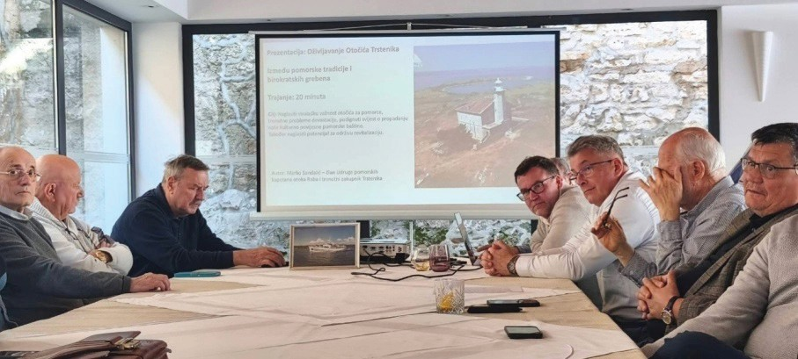
Rab, regarding a project for the revitalization of the Trstenik lighthouse, built during theAustro- Hungarian monarchy period, and included in the register of major Adriatic lighthouses.A video presentation and description of all activities lasted about twenty minutes. After brief comments and questions, it was concluded that at next year’sAssembly in Rab, the host will organize a trip to Trstenik. The proposal was accepted.
RegardingthecurrentsituationintheMiddleEast,weinvitedthePresidentoftheSeafarers’ UnionofCroatia,Mr.NevenaMelvan,topresentthelatestinformationonthenumberofseafarers who are trapped in the Persian Gulf.
Mr.MelvanstatedthatafewdaysagoameetingwasheldatMPPIwithunions,Mare Nostrum(shipowners),andrepresentativesoftheministriesofForeignAffairs,Interior,andothers.
Theconclusionisthatthereisconfirmedinformationaboutaround225seafarers,butit is assumed that there are more who have not reported via CIMIS - Croatia Integrated Maritime Information System.
Media reporters were present during meeting, and several interviews were given to TV reporters regarding situation in Gulf region as many Croatian seaman are there at present.
We urge our collegues to get in contact with our consulates in the area and register there presents.Localassociationwillbepostingcontactdetailsofconsulatesintheareawheretheycan register them self.
Capt.VičevićinformedtheassemblythattheAssociationRijekastilldoesnotwishtoreturn to the Community.
Capt. Damir Lakoš informed us that CESMA has nominated us to organize the CESMA AGA2028. There are preliminary discussions that the host could be theAssociation of Captains Split.ThePresidenthastakenontheobligationtoexplorepossibilitieswithrelevantstakeholders on how to secure financing for the organization and will soon inform the Presidency.
There was also discussion about rejuvenating the membership, but no conclusion has yet been reached. There is still on-going problem in most of ZHUPK members to attract younger generation of captains to become memeber or to take more active roll in their local association.
ZHUPK, CROATIA

FROMAFCAN
AGAATLEHAVRE25TH&26THMARCH
TheAGAoftheFrenchAssociationofShipCaptains(AFCAN)tookplaceonMarch25and 26, 2026 in Le Havre.The results of last year are very positive, withAFCAN counting more and more members.
Beyond interventions on multiple subjects such as maritime safety, legal, ISM or ISPS, the associationwasingreatdemandduringtheyear2025topreservetheinterestsofitsmembers,who did not hesitate to ask for the support and advice of experienced captains.
In addition to questions relating to internal functioning, world news has led to abundant constructive debates against a backdrop of geopolitics. Attacks on ships and maritime security, the worrying growth of the dark fleet, transgressions of international regulations, the spread of conflicts and the difficulties encountered at the IMO are at the heart of the concerns of many Captains.AFCANremainsincontactandsupportssailorsimpactedbythesituationinthePersian Gulf.
The general assembly was also an opportunity forAFCAN members to meet students from the ENSM (Ecole Nationale Supérieure Maritime – French Maritime School). We thank the students for their presence and their curiosity through the many questions asked, as well as the management of the ENSM for their welcome.
AftereightyearsasPresidentof AFCAN,Capt.PierreBlanchardhandedoverthehelm to Capt. Mathieu LE BRIS. Through his various assignments, Capt. Mathieu LE BRIS was able to take part in numerous military, industrial and specialized maritime logistics missions. He participated in the transport ofAriane, Soyuz and Vega rockets for the European SpaceAgency, but also worked with NASA, notably for the maritime transport of the James Webb telescope.
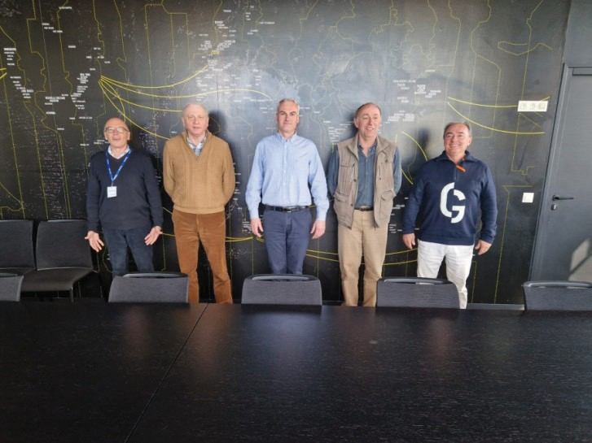
The newAFCAN Board
Capt.HubertARDILLON CESMASecretaryGeneral–AFCANVice-president

STORYABOUTTRSTENIKISLETINCROATIA
An interview of Mr. MARKO SANDALIĆ, Entrepreneur,Manager,andMaritimeSafetyInspector on a Lifelong Mission
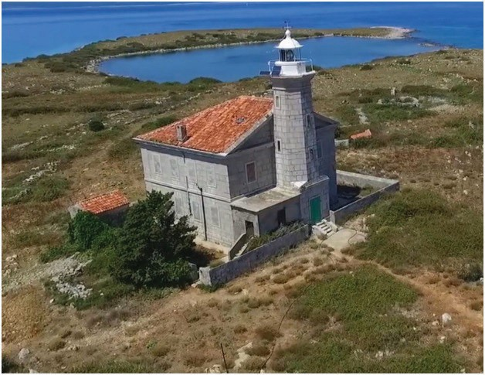
Mr.Marko SANDALIĆ’s story of love for the sea, the profession, nature, and maritime heritage: “This is not a project for profit. This is a project to save souls, tradition, and common sense.”
CESMA:HowdidyourstorywiththeisletofTrstenikbegin?

Marko:ItbeganwithafascinationforthissmallbutuniquelypositionedisletintheKvarner Gulf.As a child, I often fished near Trstenik with my father or picked wild asparagus among the rocks.Itsbeautyalwayscaptivatedme.LocatedeastoftheislandofCresintheopensea,Trstenik has long been a vital landmark for mariners. If you ask about my motivation, it is a place that carries stories, memories (both beautiful and tragic), and the potential for something positive and sustainable.
ThepeopleoftheislandofRabwhereIlive,feeladeepconnectiontoTrstenik,particularly due to the tragedy of 1962. By some twist of administrative fate,Trstenik belongs to Mali Lošinj territorially, yet it remains under the Rab Land Registry. This prompted us, the members of the Association of Sea Captains of the Island of Rab, to initiate a project for the reconstruction of the southwestern “Portić” (small harbor).
Trstenik represents a cultural and traditional treasure. For generations, its waters fed the familiesofsailorsandfishermenfrombothLošinjandRab.Itservedasasanctuaryduringstorms—a refugefromtheBuraandJugowinds.Sadly,onApril27,1962,astormnearthesoutheasterncape claimed21lives-aboatmanandstudentsfromthemaritimeandeconomicschoolsinMaliLošinj returning home to Rab. For decades, the “Portić” on the southwest was the place where weary bodiesandsoulsfoundcalm.Today,however,yearsofneglectanderosionhavelefttheharborin a dilapidated state, making it unsafe to enter. Soil erosion and the undermining of the waterfront have scattered rocks across the seabed, reducing depth and directly endangering maritime safety.

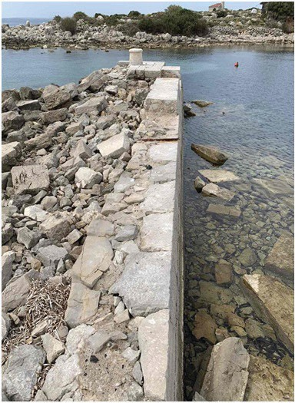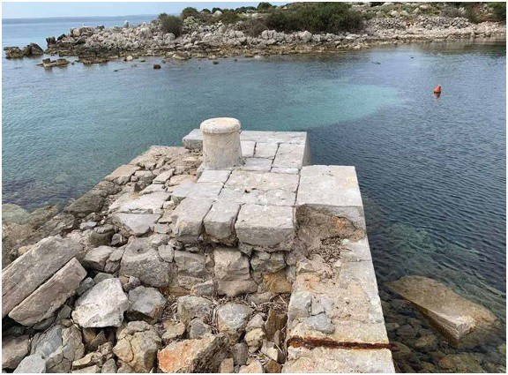
CESMA:Whatstepshavebeentakentoaddress this?
Marko: Using the Association’s funds, we completed the full project documentation and geodetic studies.We reached an agreement with the landowner, the Diocese of Krk, to define the maritimedomainboundaries.WeintendedtoapplyforMinistryoftheSeafundsfortherestoration ofmaritimedomainsoutsideportareas.SinceTrstenikisspatiallyplannedunderMaliLošinj,we delivered the ready-to-use documentation to the City of Mali Lošinj to apply for the tender.
However, for three consecutive years, we received no response. I believe politics played a roleinthislackoffunding.AsamemberofthePresidencyoftheAssociationofSeaCaptainsof theRepublicofCroatiaandanexperiencedmaritimesafetyinspector,Iopenlycriticizethislack of communication. Maritime safety is no place for improvisation. I humbly call upon the City of Mali Lošinj for cooperation; this isn’t about ego—it’s about human lives and heritage.
When I saw the project stalling, a sense of defiance kicked in, fueled by my love for that rock.Mycompany,KompetencijaL.L.C.,nowleasestheisletfromtheDioceseofKrk(excluding the maritime domain and the lighthouse building). Shortly after, we established OPG Trstenik (Family Agricultural Farm).
CESMA:WhatismostsignificantaboutTrstenikfromahistoricalormaritimeperspective?
Marko:Verylittleiswidelyknownaboutit.Themostprominentstructureisthelighthouse, built in 1873 during theAustro-Hungarian era. It remains functional and automated today, with a signal visible up to 11 nautical miles.
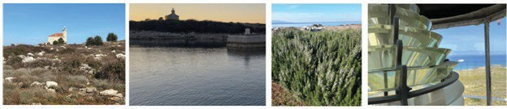
The problem is that the lighthouse keeper’s house is deteriorating. I want to protect this “monument to seamanship,” but we are stuck in administrative limbo awaiting the new Plovput Actsothehousecanbeputoutforconcession.Ourconceptisn’tastandard“lighthouserental”for tourists.Wedon’thavemegalomaniacalambitionsforcampsites;wewanttorestoretheislandto itsoriginalstate.Trstenikismuchmorethanjustatower;it’saseriesof“mini-oases”thatvisitors can experience through thematic tours.

CESMA:Youmentionedthe1962tragedy.Arethereotherstories?
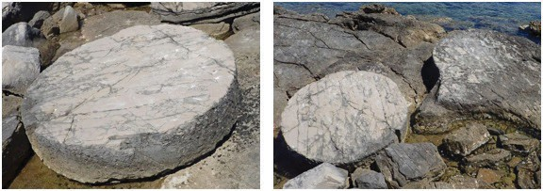
Marko:Thetragedyofthestudentsispartofourlocalmaritimememory,whichiswhywe owe that site great reverence. But there are other untold stories. Recently, three large millstones werediscoveredonthenortheastcoast,blendingintotherocks.Weintendtodocumentthesefacts for future generations.
CESMA:Whatmotivated theagricultural(OPG) andtourism development?
Marko:OPGTrstenikcurrentlyfocusesonolivegrowing.In2025,weharvestedabout400kg of olives and produced 50 liters of premium, unique olive oil which we named “Lantemika”. The land hadn’t been touched in 50 years, and the conditions were extreme, but my team carried everything by hand to Rab.
Thenaturalolivegroveisatreasure,butitisdevastatedbybramblesandcollapseddry-stone walls. Due to environmental protection (Natura 2000) and logistics, we use only hand tools. We are also assessing other crops; while wild immortelle thrives, the island’s famous wild asparagus has mysteriously vanished in recent years.
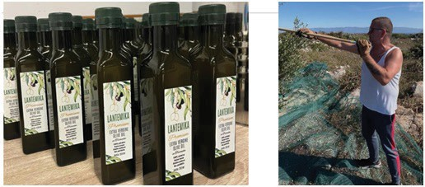
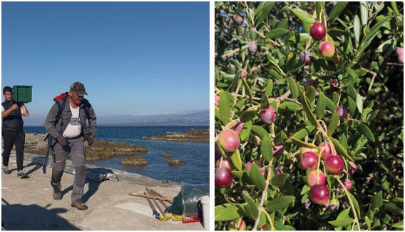
Trstenikisnotformasstourism.Itisforthosewhorespectnatureandhistory.Beforeopening ittothepublic,weneedatleasttwoyearsofrestorationwork:clearingpaths,repairingdry-stone walls, and restoring the lighthouse building.
CESMA:Whatlegaloradministrativehurdleshaveyoufaced?
Marko:Administrationisthebiggesthurdle.BecauseTrstenikisregisteredinRabbutplanned in Lošinj, I am stuck in a “no man’s land.” The City of Rab couldn’t grant agricultural subsidies because of the spatial plan, and Mali Lošinj couldn’t because my company is headquartered in Rab. Every door seems closed, but we won’t be discouraged.
CESMA:Whatarethefuturepriorities?

Marko: If we secure the lease for the lighthouse house, we will focus on eco-production andculture.Weneedtocreateconditionsformulti-daystaystoworkproperly.Iamconsideringa memorial center in one of the rooms to honor the youth lost in these waters.
Logisticsisourgreatestrisk.Maritimesafetyismyprofession,soIwillapplymymanagement expertise to ensure transport is handled with the highest standards. We are not just looking at summer operations, but months when the sea is unforgiving.
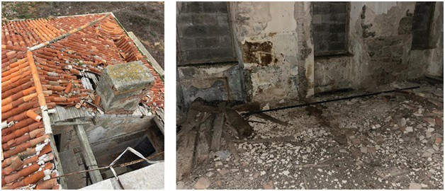
Beyond that, we want to offer organized tours focused on spirituality, maritime education, andnature.Iamamanagerbyprofession—Iknowprojectsarerealizedthroughlaborandsacrifice, not just ideas.
CESMA:Youmentionedresearchinghistoricalrecords?
Marko: Yes, searching for the Lighthouse Keeper’s Logs is a priority. These logs aren’t just technical data; they are a record of nights when the Bura sliced the sea like a knife, and the light was the only certainty in the Kvarner. They contain the true story of Trstenik—a story of responsibility and quiet devotion.
There is also a fascinating lead from Captain Lucijan Kapiteli, who grew up on the island. He mentioned a graveyard of three German soldiers from WWII. We haven’t found it yet, but records suggest keepers saved 17 German soldiers from the sea before they were surrendered to Allied forces. We want to find and mark these graves out of respect.
FromOceanTankerstoRab’sDry-StoneWalls
CESMA:Yourresumereflectsademanding,globalsystem.Canyoushareyourprofessional background?
Marko: First of all I am a very proud member of Cratian Captain’s association. My professionisnotbuiltonimprovisation.Iamamarinerbyeducationandcalling.Igraduatedfrom the Maritime School in Bakar, the Faculty of Maritime Studies in Dubrovnik, and later Lloyd’s Maritime Academy in London.
IservedasadeckofficeronVLCCtankersandtransitionedintoamaritimesafetyinspector andmanager.I’veledsafetyoperationsformassiveglobalprojects:thePalmIslandsinDubai,and oilfieldsinthePersianGulfandGulfofMexico.IproudlyservedastheHSE(Health,Safety,and Environment)ManagerforbothcontainerterminalsinRijeka—BrajdicaandtheRijekaGateway project (part of the global Maersk group).

Today, through my company Kompetencija LLC, I work as an independent marine and offshoreconsultant.OneofourmajorclientsistheAbuDhabiNationalOilCompany(ADNOC). This work provides a very realistic view of the world.
CESMA:Howdoesaninternationalcareerfitwithadesolate islet?
Marko:(Laughs)That’sexactlywhyitfits.Trstenikisnotaromanticwhim;itisan“offshore” projectinminiature.Exposure,weather,logistics,andsafety—it’sallthere.Theonlydifferenceis I don’t have a corporate budget behind me. If you fail here, it’s visible immediately, and you pay for it personally.
CESMA:Wheredo youseeyourself inten years?
Marko:IfTrstenikissecure,dignified,andrespectedintenyears,Iwillbesatisfied.Ifnot, atleastTrstenikwillknowsomeonedidn’tgiveupwithoutafight.Thisisn’taprojectofego;it’s a project of character.And the sea knows exactly who is who.
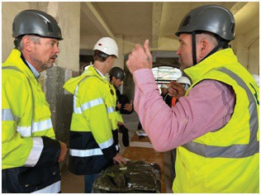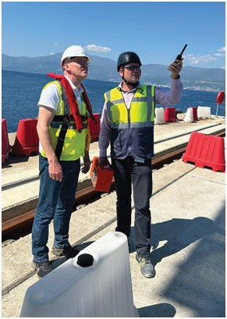
ZHUPK, CROATIA

CESMALOGBOOK(2026-1)
Wewererepresentedatthefollowingoccasions:
27/JANUARY CESMA1stVIDEOMEETINGCOUNCIL

24/MARCH MARITIMETECHS.1.1–AIANDINNOVATIONFORUM,
N.VAPTZAROVNAVALACADEMY,VARNA,BULGARIA

Onthefrontpage:
20YEARSOFMARITIMELABOURCONVENTION(2006)
GAZCARRIERARCTIC-METAGAZINMEDITERRANEANSEAAFTEREBURNING DIDAMAR (LITTLE QOIN) ISLAND IN HORMUZ STRAIT
VLCCONAPPROACHTOKHARGISLANDTERMINAL(IRAN)

(abridged)

AIMS OFTHE ORGANISATION
- TOWORLDWIDEPROTECTTHEPROFESSIONALINTERESTSANDSTATUSOFEUROPEAN
SEAGOINGSHIPMASTERS.
- TOPROMOTEMARITIMESAFETYANDPROTECTTHEMARINEENVIRONMENT.
- TO PROMOTE ESTABLISHMENT OF EFFECTIVE RULES WHICH PROVIDE HIGH PROFESSIONAL MARITIME STANDARDS AND PROPER MANNING SCALES FOR VESSELS UNDER AN EUROPEANNATION FLAG.
- TOINFORMTHEPUBLICINTHEEUABOUTDEVELOPMENTSINTHEEUROPEAN
MARITIMEINDUSTRYANDTHOSECONCERNINGSHIPMASTERSINPARTICULAR.
- TOCO-OPERATEWITHOTHERINTERNATIONALMARITIME ORGANISATIONS.
- TORETAINANDDEVELOPTHEHIGHESTMARITIMEKNOWLEDGEANDEXPERIENCE
IN EUROPE.
- TOBEINVOLVEDIN RESEARCH CONCERNINGMARITIMEMATTERSIFAPPLICABLEIN
CO-OPERATIONWITHOTHEREUROPEANINSTITUTIONSAND/ORORGANISATIONS.
- TOASSISTMEMBERSHIPMASTERSWHOENCOUNTERDIFFICULTIESINPORTS
WITHINTHEREACHOFNATIONSREPRESENTEDBYCESMAMEMBERASSOCIATIONS
- TOPROMOTETHESEAFARINGPROFESSIONINEUMEMBERSTATES

ANNUALSUBSCRIPTION:
EURO16.00PERSEAGOINGMASTER(WITHAMINIMUMOF25) EURO8.00 PER SEAGOING MASTER FOR ASSOCIATED
MEMBERASSOCIATIONS(WITHAMINIMUMOF25)

LISTOFCESMAMEMBERSANDREPRESENTATIVES

NAME – COUNTRY REPRESENTATIVE
WEBSITE CONTACT

VDKS–GERMANY CAPT.WilhelmMERTENS
www.vdks.org office@vdks.org

AFCAN– FRANCE CAPT.HubertARDILLON
www.afcan.org courier@afcan.org

HYDROS– FRANCE CAPT.FrancisVANOOSTEN
https://hydros-alumni.org associationhydros@gmail.com

NVKK– NETHERLANDS CAPT.HansAMMERLAAN
www.nvkk.nl info@nvkk.nl

CTPC–ITALY CAPT.MilenaMODUGNO
www.collegiocapitanitrieste.it collegio69@collegioditrieste.191.it

CNPC–ITALY CAPT.GiovanniLETTICH
www.collegionazionalecapitani.it info@collegionazionalecapitani.it

USCLAC–ITALY CAPT.AntonioRAGGI
www.usclac.it segreteria@usclac.it

IYM – ITALY
www.italianyatchmasters.com secretary@italianyachtmasters.com

ACCMM– SPAIN CAPT.MarianoBADELLSERRA
www.capitansmercants.com info@capitansmercants.com

AVCCMM–SPAIN CAPT.PatxiODIAGAGOROSTIZU
www.avccmm.org avccmm@avccmm.org

KBZ – BELGIUM CAPT.AlainPELS
www.kbz-crmb.be secretary-general@kbz-crmb.be

IIMM – IRELAND CAPT.Aine HYDE
www.mastermariners.com cesma@mastermariners.com

ZPU–SLOVENIA CAPT.GiorgioRIBARIC
zpu.slo@siol.net

BSMA–BULGARIA CAPT.StanislasSTOYANOV
www.bsma-bg.org chairman@bsma-bg.org

LKKA–LATVIA CAPT.JazepsSPRIDZANS
www.lkka.lv president@lkka.lv

ZHUPK – CROATIA CAPT.DarkoGLAZAR
www.ukptmz.hr udruga.kapetana@zd.t-com.hr

LCC–LITHUNIA CAPT.JuozasLIEPUONIUS
www.portofklaida.lt jurukapitonuklubas@gmail.com

SINCOMAR–PORTUGAL CAPT.JoseTEIXEIRA
www.sincomar.pt sincomar.fesmar@net.vodafone.pt

HSF– FINLAND CAPT.StigSUNDBERG
sundberg.stig@outlook.com

ACNR–ROMANIA CAPT.MariusTUTUIANU
www.acnr.ro office@acnr.ro

UPKCG – MONTENEGRO CAPT.JankoMILUTIN
captain@t-com.me

HON.VICEPRESIDENTS: CAPT. W.VON PRESSENTIN HON.MEMBERS: CAPT. G. KIEHNE CAPT.J-DTROYAT ADVISORS: TBN

